Animals including Humans-Year 2

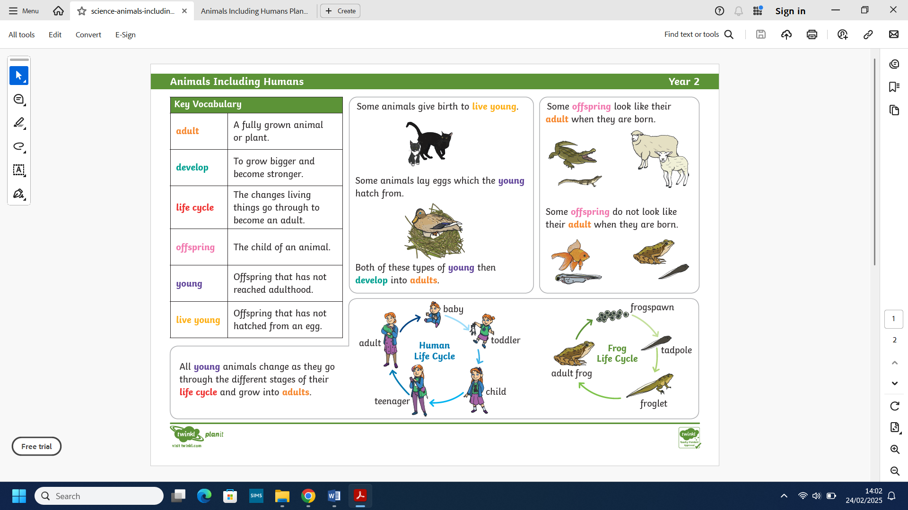
All young animals change as they go through the different stages of their life cycle and grow into adults.
What we already know:

- We can already identify and name a variety of common animals including fish, amphibians, reptiles, birds and mammals.
- We can identify and name a variety of common animals that are carnivores, omnivores and herbivores.
- We’re able to describe and compare the structure of a variety of common animals.
- We can identify, name, draw and label basic parts of the human body and say which part is associated with which sense.
Scientific skills:
- We have asked simple questions and recognised that they can be answered in different ways.
- We have observed closely, identified and classified animals.
- We have gathered and recorded data to help in answering questions.
- We can identify and classify.
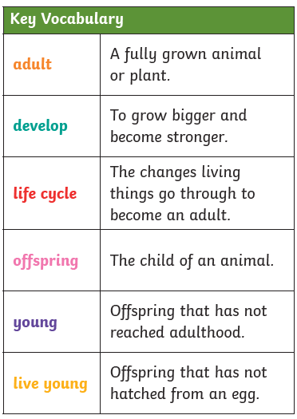
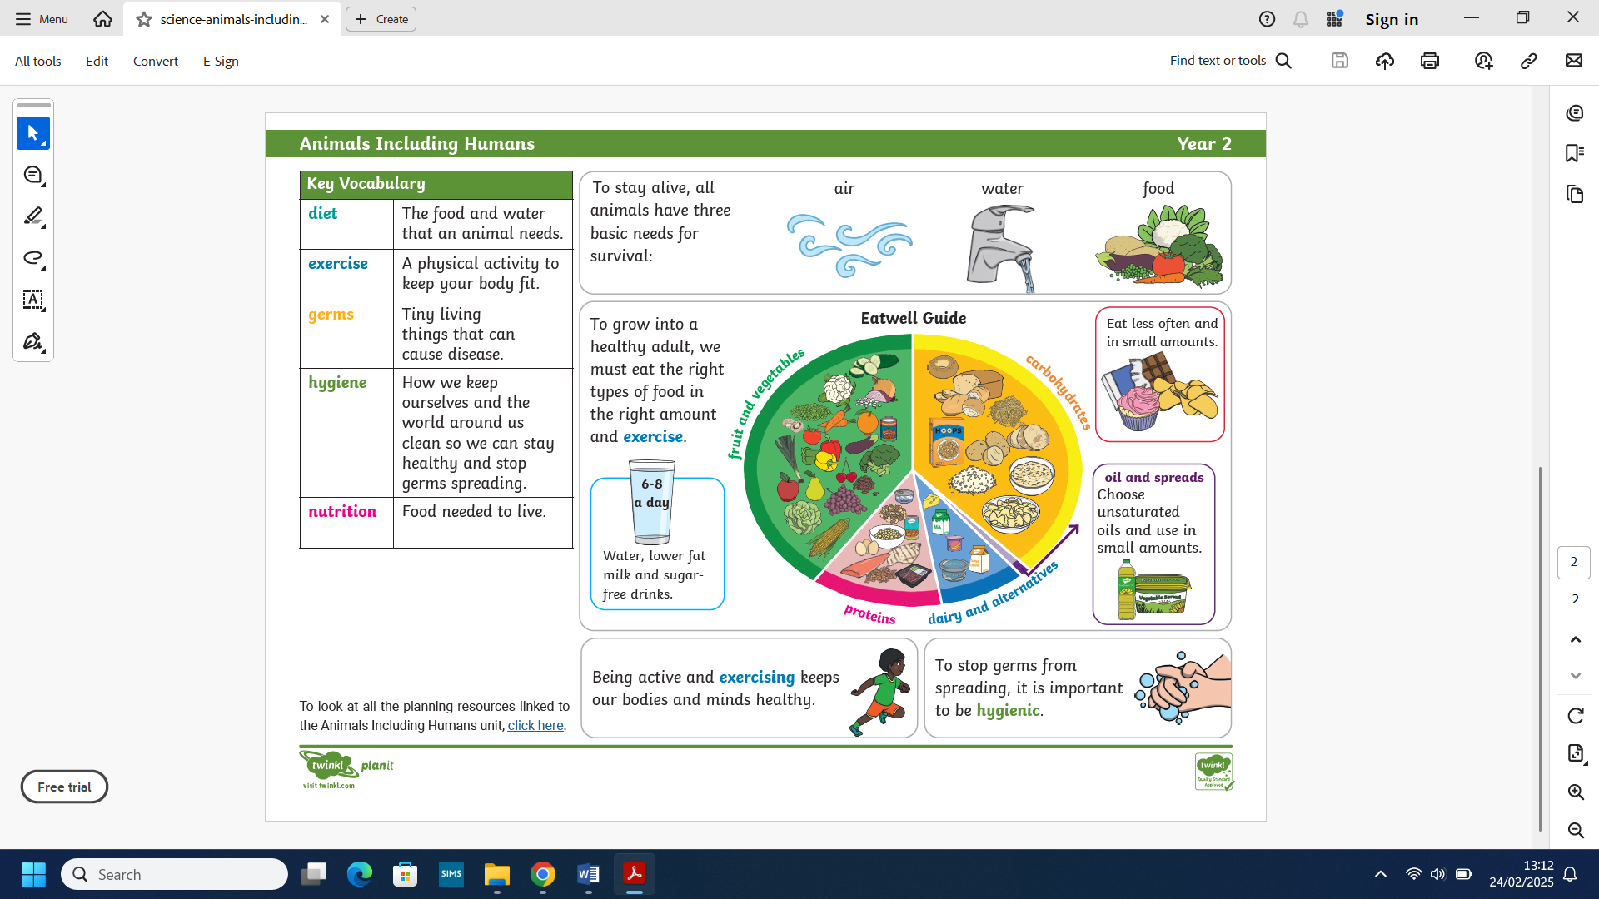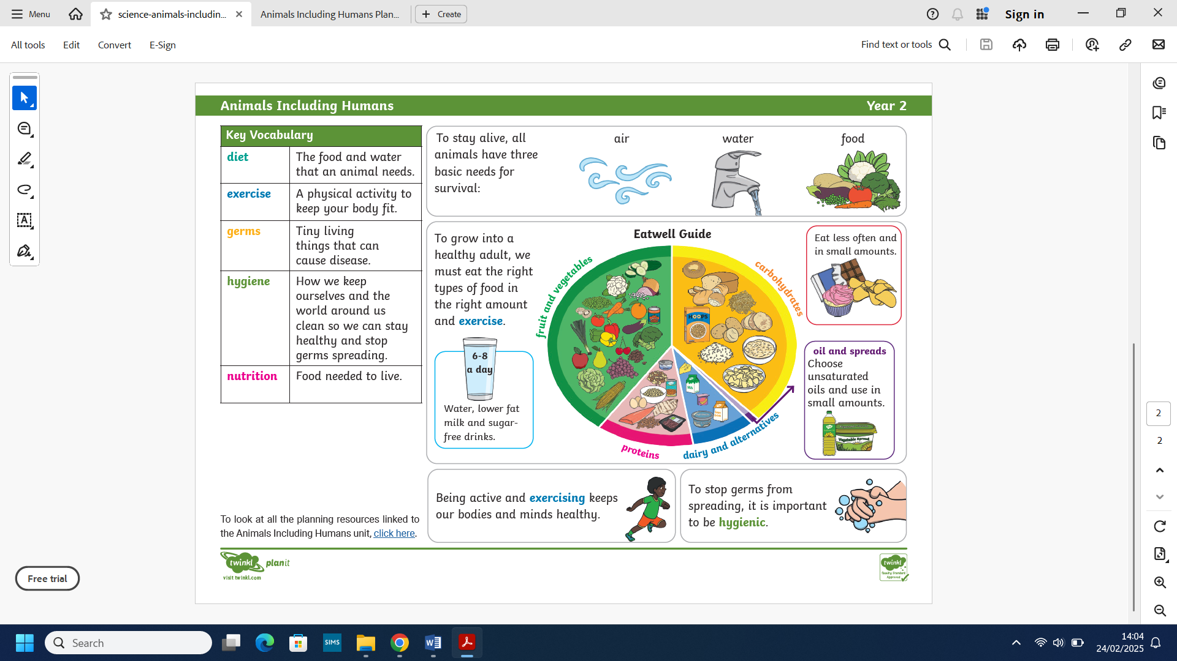
What we will know by the end of this unit:

- We will know that animals including humans have offspring which grow into adults.
- We will find out about and describe the basic needs of animals, including humans for survival.
- We will describe the importance for humans of exercise, eating the right amount of different types of food and hygiene.
Scientific skills:
- We will be able to ask simple questions and suggesting ways to find the answers.
- We will observe, gather and record information and use this to answer our questions.
- We will identify and classify.

