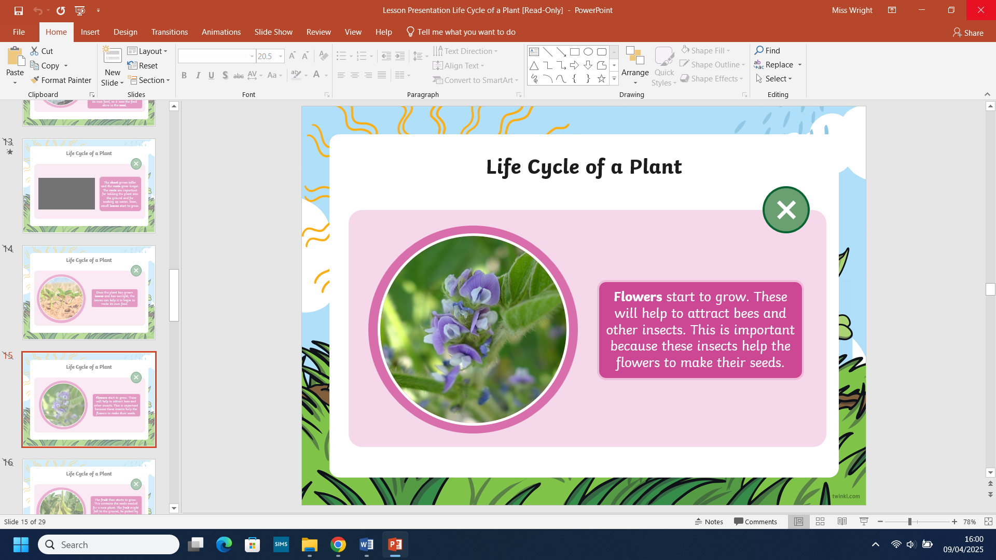
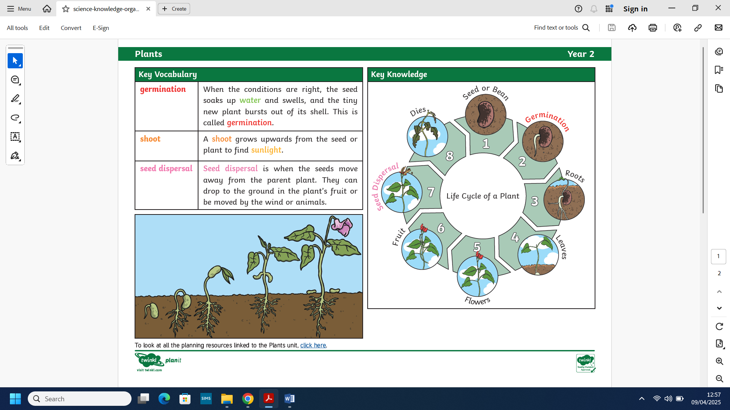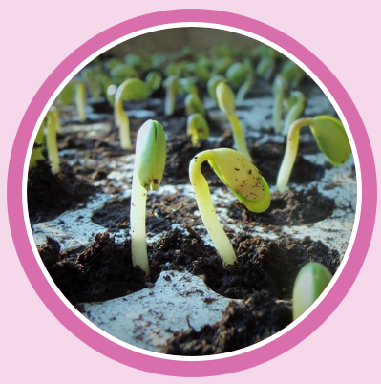
What we already know:

- We can name the seasons, observe and identify the changes that occur within those seasons.
- We can identify and name a variety of common, wild and garden plants, including deciduous and evergreen trees.
- We have learnt to identify and describe the basic structure of a variety of common flowering plants including trees including – leaves, flowers (blossom), petals, fruit, roots, bulb, seed, trunk, branches and stem.

Plants-Year 2

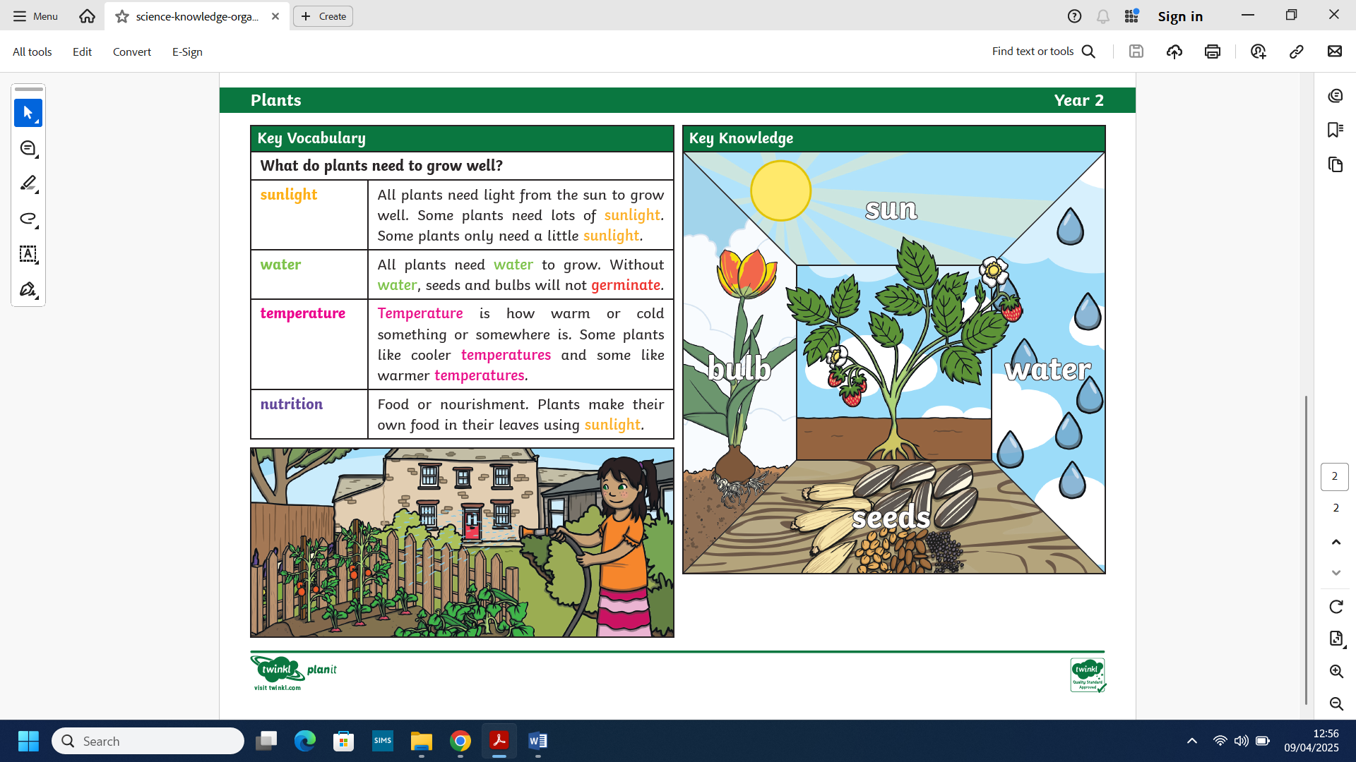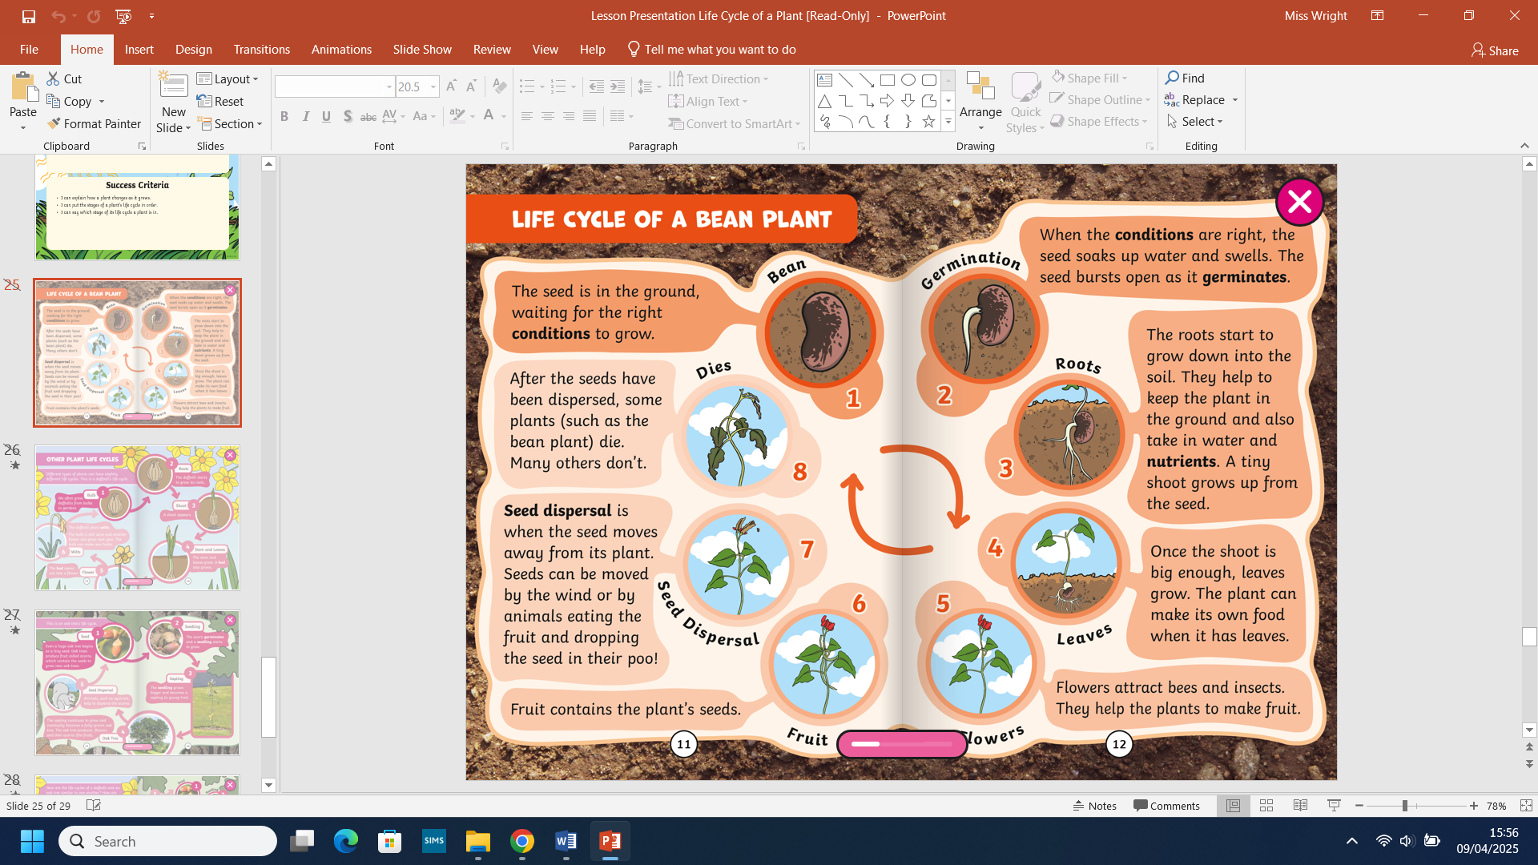
What do plants need?
What we will know by the end of this unit:

- We will observe and describe how seeds and bulbs grow into mature plants, including germination, growth, survival and processes of reproduction (a simple understanding of pollination and seed dispersal).
- We will find out and describe how plants need water, light and a suitable temperature to grow and stay healthy.

- Scientific skills:
- We will observe closely, using simple equipment.
- We will perform simple tests.
- We will gather and record observations to help in answer questions.

