Living things in their habitats-Year 2

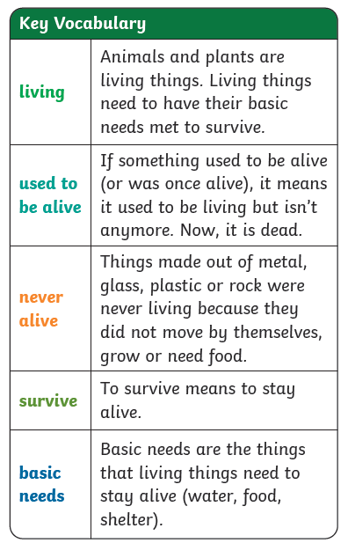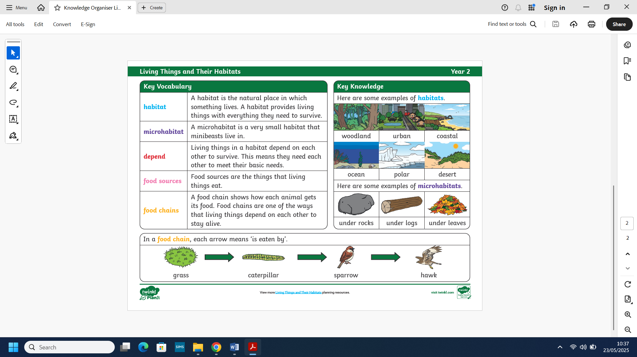
What we will know by the end of this unit:
- We will compare the differences between things that are living, dead, and never been alive.
- We will identify that most living things live in habitats to which they are suited.
- We will describe how different habitats provide for the basic needs of different kinds of
animals and plants, and how they depend on each other.
- We will identify and name a variety of plants and animals and their habitats including
microhabitats.

- We will describe how animals obtain their food from plants and other animals, using the
idea of a simple food chain.

Scientific skills:
- We will identify and classify.
- We will gather and record observations.
- We will use our observations and ideas to suggest answers to questions.

What we already know:

- We can identify and name a variety of common animals including fish, amphibians, reptiles, birds and mammals.
- We can identify and name a variety of common animals that are carnivores, omnivores and herbivores.
- Identify and name a variety of common, wild
- and garden plants, including deciduous and evergreen trees.
- We could describe the basic needs of animals, including humans for survival.
- We could describe how plants need water, light and a suitable temperature to grow and stay healthy.



