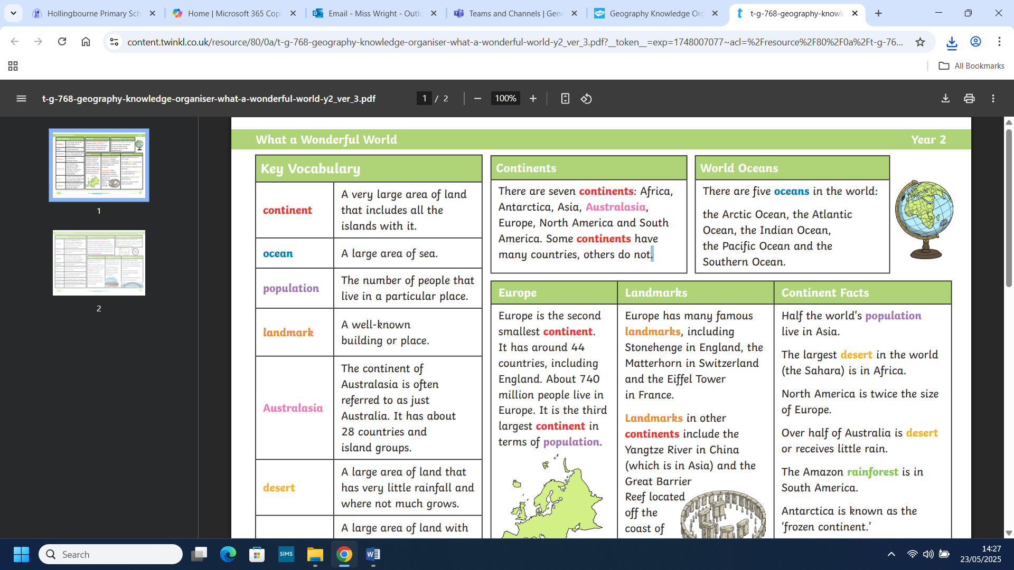
Year 2- Continents, Oceans and Rivers
What you already know

- We understand that the United Kingdom consists of 4 countries, is an island and surrounded by the sea.
- We understand that the map is a 2D representation of our 3D world and is not to scale.
- We can identify on a map what is land and what is sea.
- We have had access to and have been shown maps of the UK.
- We have begun to use simple compass directions, near and far, left and right.
- We can identify and use all key vocabulary to describe physical features such as forest, hill, river, soil.
What you will know why the end of this topic

- We will know that the United Kingdom consists of 4 countries, is an island and surrounded by the sea.
- We will identify the capital cities of the four countries in the UK and be able to name the oceans and seas that surround the UK.
- We will be able to name and identify the differences in landscape that relate to the 4 countries in the UK and key landmarks.
- We will name and locate the 7 continents and 5 oceans on a map.
- We will use atlases, globes, Google Earth and maps to locate places.
- We will use secondary sources, such as I-pads and books to research about different places.
- We will use the 4 basic compass directions, near and far, left and right and be introduced to North, East, South and West.
- We will use locational and directional language to describe locations and routes on a map.

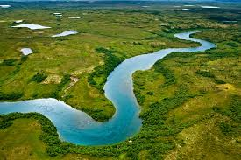
Key vocabulary
continent | A large area of land made up of several countries. There are seven continents including: Asia, Africa, North America, South America, Europe, Australia (Or Oceania) and Antarctica.
country | An area of land controlled by one Government.
landmark | An object or place that makes the place easy to recognise.
landscape | A picture of everything you can see such as mountains and rivers.
ocean | An extremely large body of salty water, much bigger than a sea. There are five oceans in the world including: Arctic Ocean, Atlantic Ocean, Indian Ocean, Pacific Ocean and the Southern Ocean.
sea | A big body of water, smaller than an ocean.
United Kingdom | The United Kingdom is a collection of countries including: England, Wales, Scotland and Northern Ireland.



