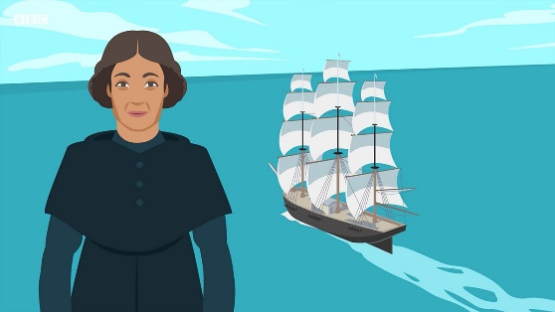
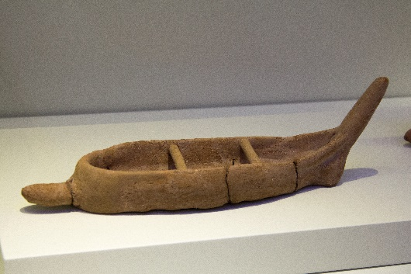
￼
Key Vocabulary:
pinch, smooth, manipulate, mould, attach, indent, patterns, texture, clay, carve, modelling
tool.
What you will know by the end of this unit:
Sculpture: You will be able to use sculpture to develop and share your ideas, experiences imagination.
You will continue to explore the properties of clay. You will learn to se tools to create patterns and texture whilst using clay imaginatively. You will learn how to roll clay evenly. You will be able to pull out projections from a ball of clay. You will learn to create holes in a ball of clay. And make simple pinch/pots and decorate. You will learn to make rolls and experiment with them, explore length and diameter of rolls and consider what they can be made into. You will make a character using a roll, selecting a length and size of roll, create a pattern on it and score eyes, eyebrows, a nose and a mouth to give it a personality.
We already know:
Sculpture: You can explore the properties of clay with your hands and know how to se objects to
make impressions in clay. You can investigate pulling, twisting, rolling, squeezing and shaping clay.

