Geography Knowledge Organiser
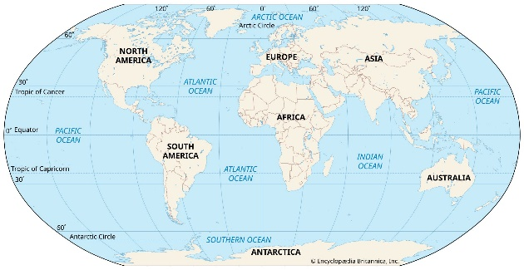
How is the climate in Jamaica different to the UK?
We already know:
You will know that there are 4 seasons in the UK and the weather patterns and features that relate to these seasons. For example- leaves falling from trees in autumn.
You will be able to identify on a map what is land and what is sea.
You will have begun to use simple directions such as near and far, left and right

What you will know by the end of this unit:
Sense of place: You will understand comparisons between the UK and Jamaica as islands within the context of Mary Seacole.
Physical geography: You will know that there are 4 seasons in the UK and the weather patterns in Jamaica are very different to the UK.
Geographical skills: You will be able to use atlases, globes, google earth and maps to locate places. You will be able to use secondary sources, such as I-pads and books to research about different places.
Key Vocabulary:
Climate
North
South
East
West
Equator
North/ South Pole
Seasons
Weather

