Living things and their habitat – Yr 5/6
Key vocabulary
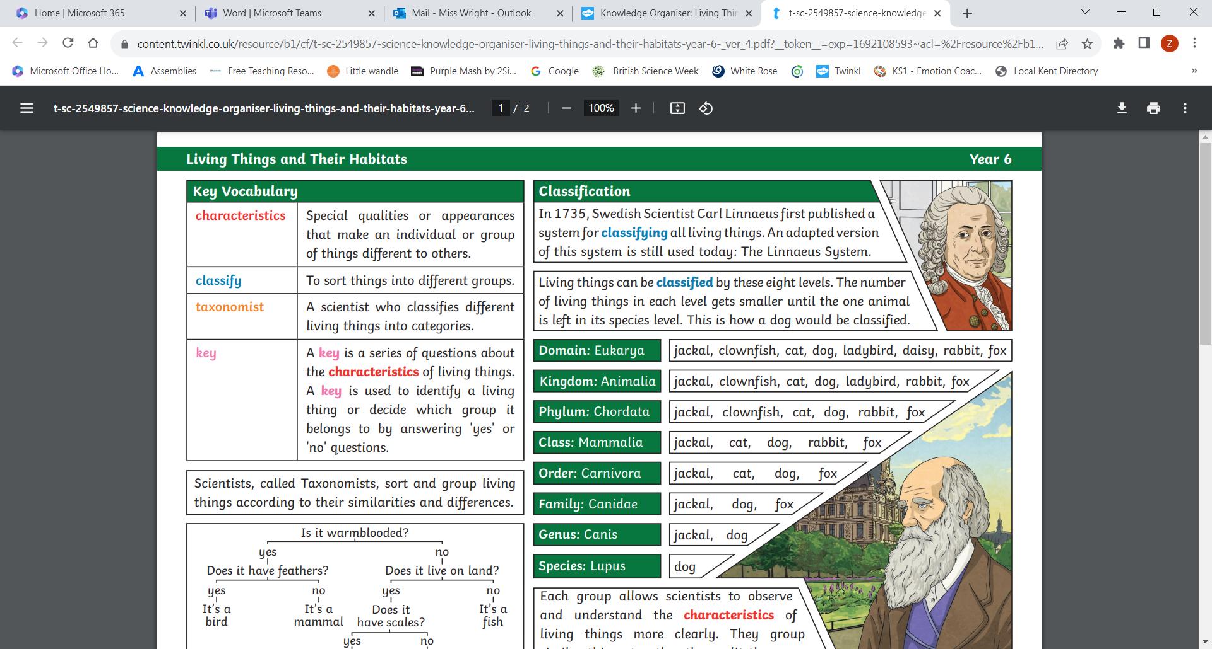

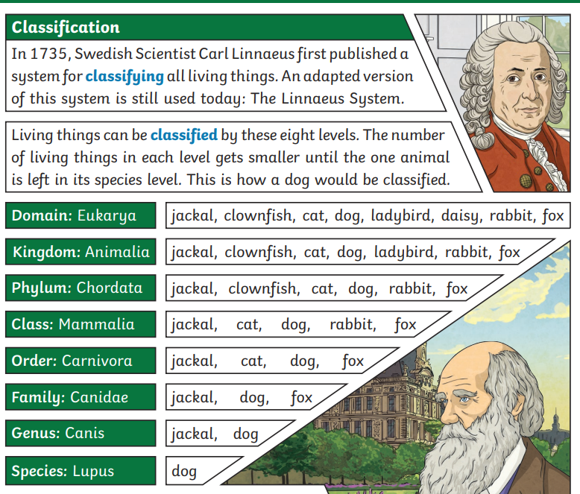

What you already know:
- You can identify and describe the functions of different flowering plants, including roots, stem, trunk, leaves and flowers.
- You’re able to explore the part that flowers play in the life cycle of flowering plants, including pollination, seed formation and dispersal.
- You can group living things in variety of ways.
- You know the terms: vertebrate, fish, amphibians, reptiles, birds, mammals, invertebrates, snails, worms, spiders and insects.

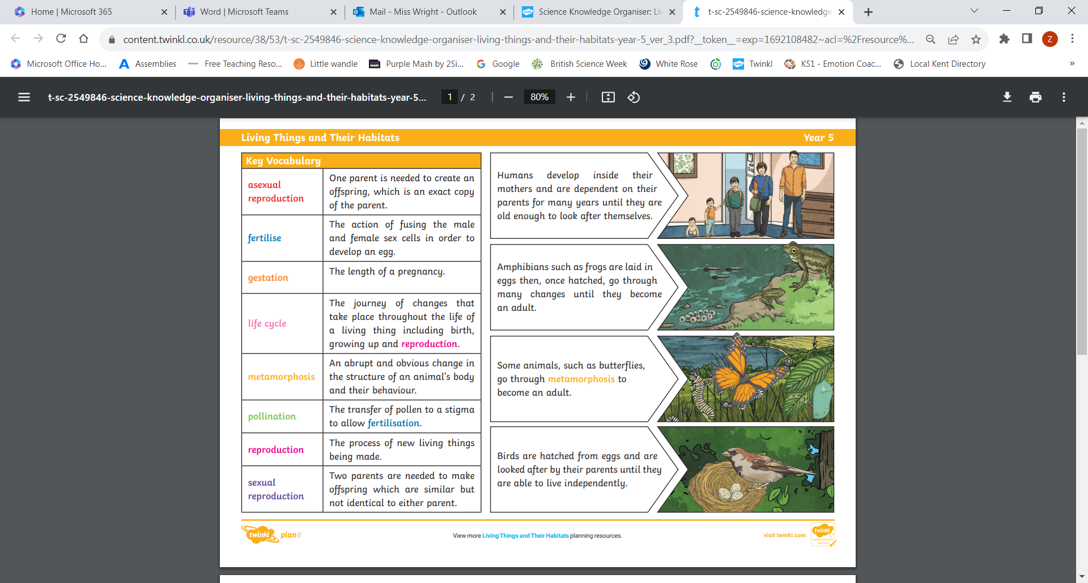

What we will know by the end of this unit:

- We can describe the life process of reproduction in plants (sexual and asexual) and animals.
- We can describe the reproduction and life cycle of different animals such as: mammal, insect, bird, amphibian.
- We can compare the life cycles of plants, mammals, amphibians, insects and birds.
- We can reflect upon how scientists have contributed to our knowledge and understanding of life cycles and reproduction e.g. Attenborough and Goodall.
- We can give reasons for classifying animals based on their similarities and differences.
- We can describe how living things (including micro organisms) are classified into groups according to the Linnaean System.
- We can use scientific enquiry skills to investigate living things in a local habitat. We will plan a fair test, record and present accurately in a spreadsheet and identify any casual relationships. We will fully reflect upon our findings.

