Key vocabulary
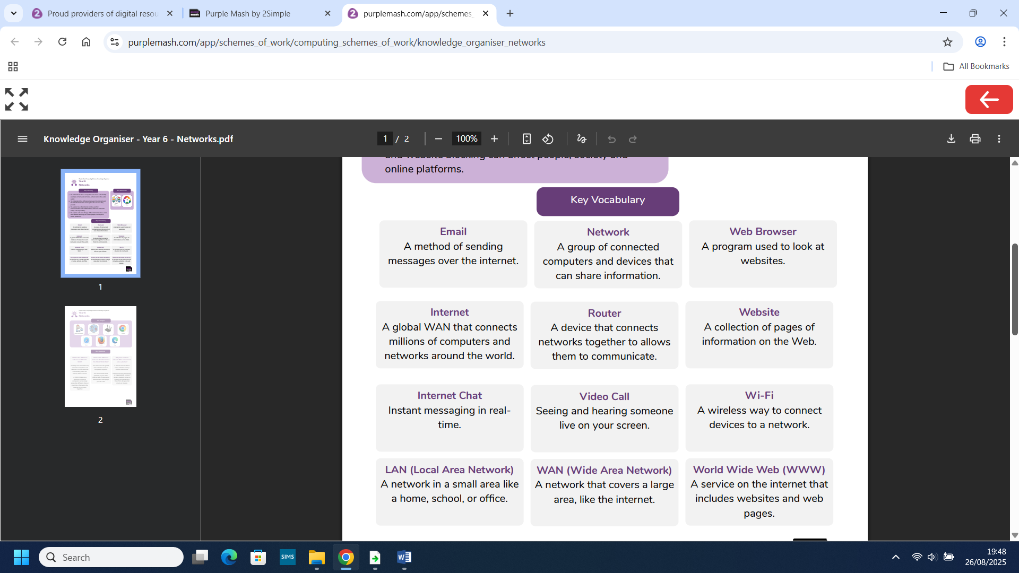
What we already know:
- You understand how the internet, the World Wide Web and a browser work together.
- You understand the different types of hardware used to access the internet and their functions.
- You have explored how hardware and software interact to complete everyday tasks.
- You understand the difference between a website and a webpage and use a school website to find information.
- You understand the difference between a browser and a search engine, and to practise searching for information safely.

Year 5&6 Networking

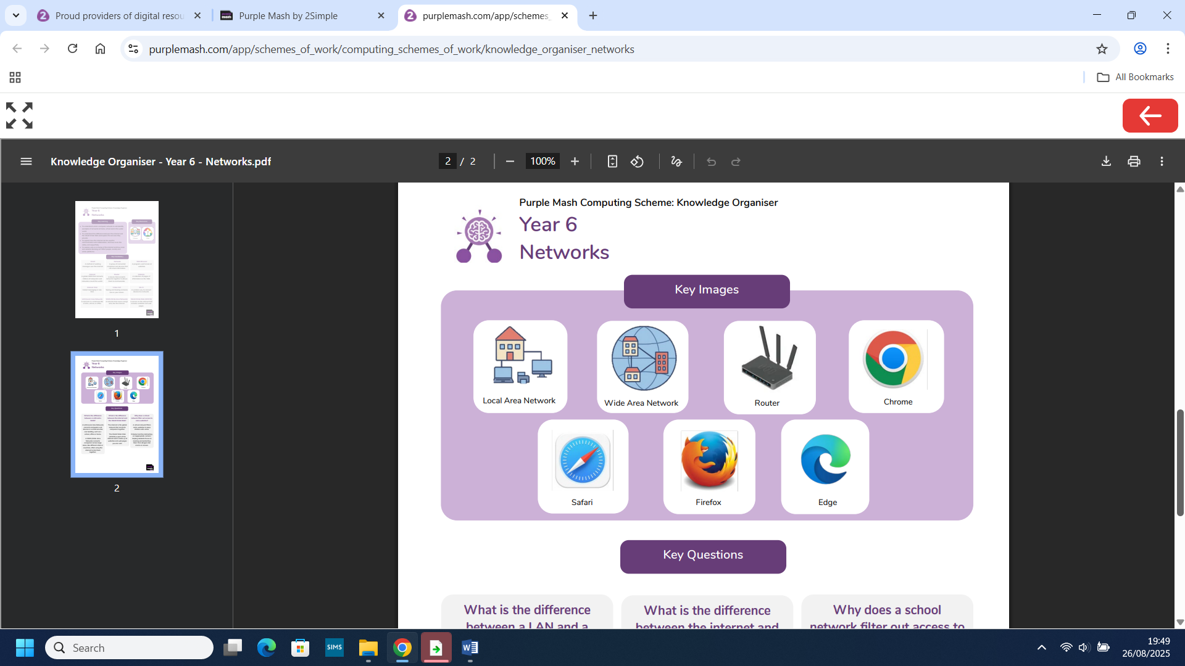
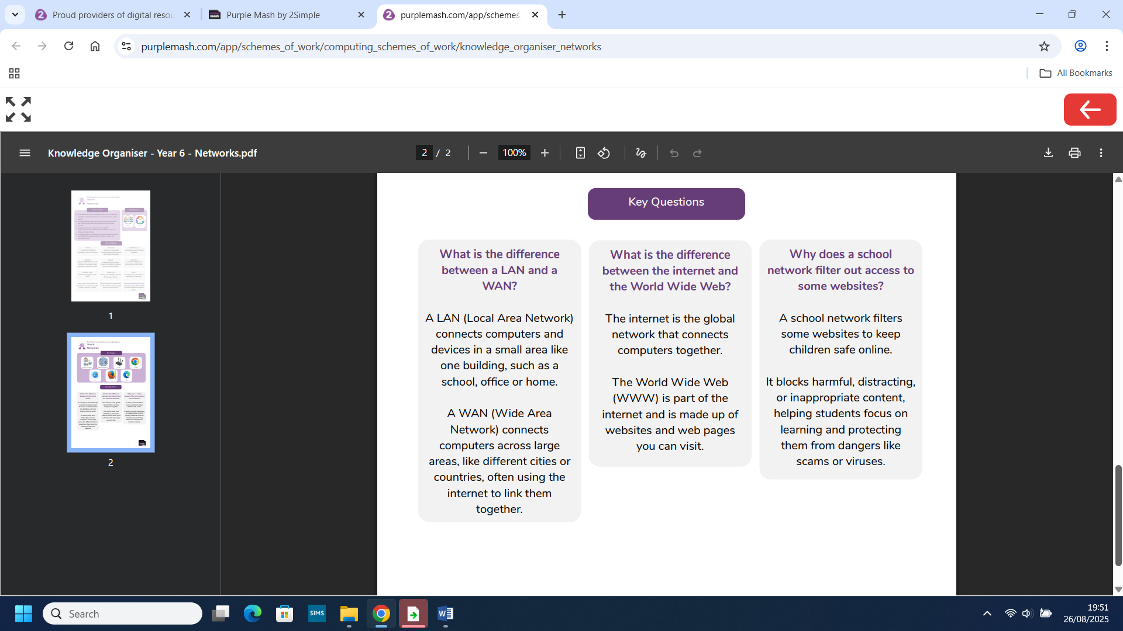
What we will know by the end of this unit:

- You will understand what a computer network is and identify examples of networks at home, school and in the wider world.
- You will understand the difference between the internet and the World Wide Web and explore the services they provide.
- You will explore how the internet can be used for communication and collaboration, and how to do this safely and respectfully.
- You will explore who is in charge of the internet and how rules and website blocking can affect people, society and online platforms.

