Key vocabulary
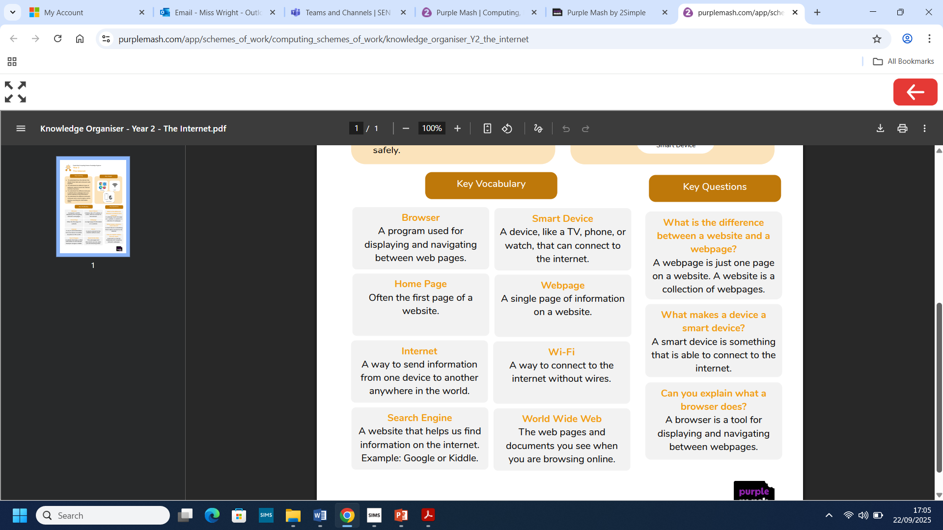
Year 2 The Internet
What we already know:
- You know what the word technology means.
- You know what technology is used in school.
- You have considered the purposes of technology used in the wider world.
- You understand the safe use of technology devices.

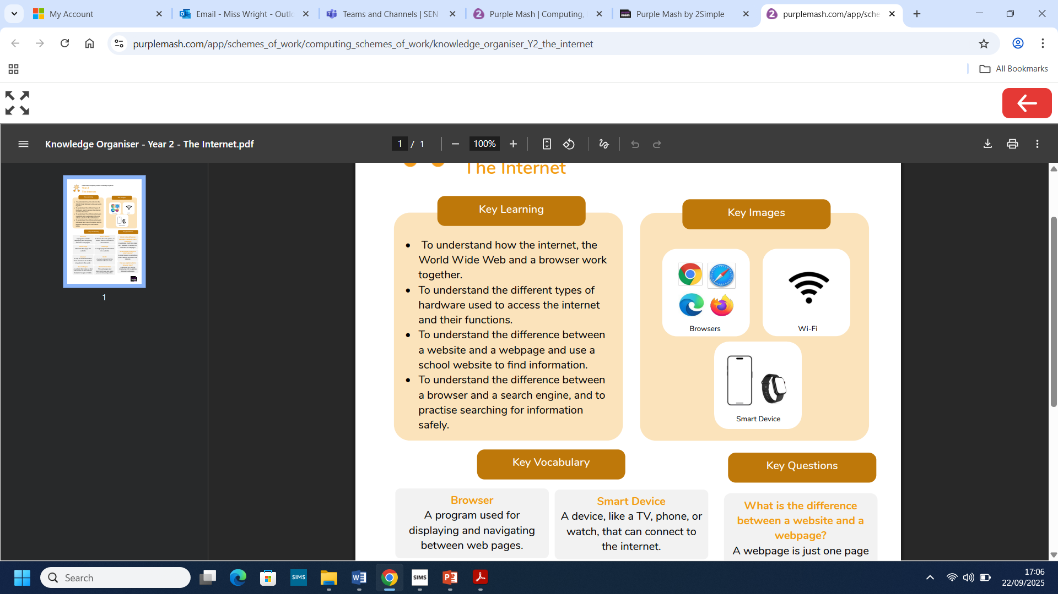
What we will know by the end of this unit:
- You will understand how the internet, the World Wide Web and a browser work together.
- You will understand the different types of hardware used to access the internet and their functions.
- You will understand the difference between a website and a webpage and use a school website to find information.
- You will understand the difference between a browser and a search engine, and to practise searching for information safely.

