What we will learn in this unit:
We will define the terms theist, atheist and agnostic and give examples of statements that reflect these beliefs.

We will give two reasons why a Christian believes in God and one why an atheist does not.

We will express thoughtful ideas about the impact of believing or not believing in God on someone’s life.

We will present different views on why people believe in God or not, including our own ideas.

What we already know:
We can describe some of the ways in which faiths such as Christianity describe God.

We can identify how and say why it makes a difference in peoples’ lives to believe in God.

We can ask questions and suggest some of our own responses about God.

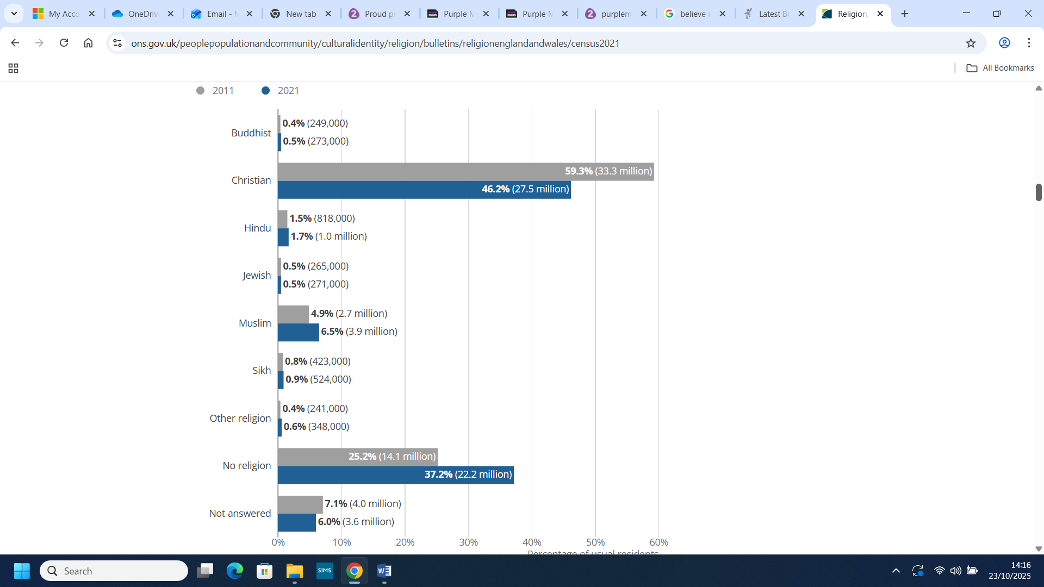

Census 2021

Religious composition, 2011 and 2021, England and Wales

Key vocabulary:
Agnostic: a person who cannot say if God exists or not.
Atheist: a person who believes there is no god.
Theist: a person who believes in God.

Why do some people believe God exists?


