Beech Class Term 2 Newsletter

TERM TWO - Key information
PE every Friday afternoon, children should wear their PE kits to school.
Miss Wright to teach alternate Thursdays.
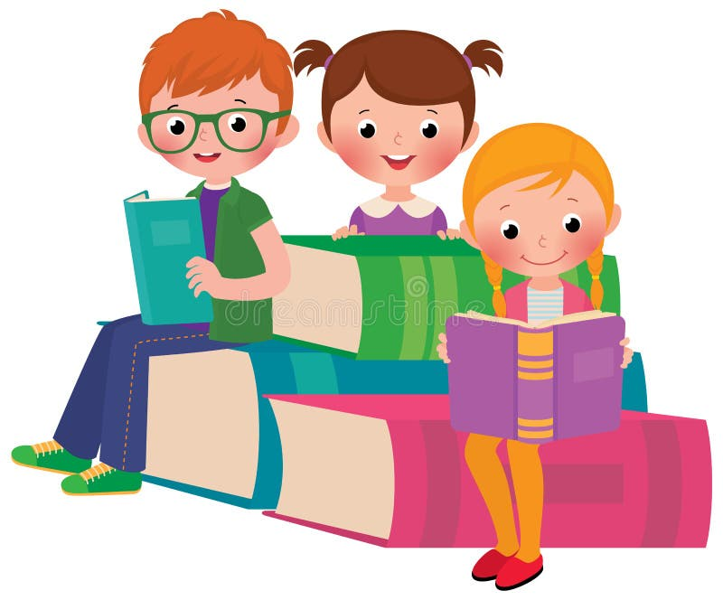
Reading Books: All pupils will have a reading record book, this is to keep track of the reading they do both at school and home. Please feel free to write extra comments in your child’s reading book should you like to, which I will keep track of. Every read at home will be rewarded with two house points. Reading records and reading books are collected every day.
Homework and spellings: These will be sent out each Thursday for you to help your child with. Homework is due the following Wednesday. Homework Club is run on a Wednesday during lunchtime for anyone who has not completed their homework.
How to get in touch: I will be available on the gate at the end of each day if you would like a quick chat about anything, or you can arrange an appointment via the office if you require. Throughout the year, there will be parent’s evenings, celebration of learning events as well as other events.
How you can help your child at home:
• Listen to them read, ask them questions about what they have read to check their comprehension.
• Team read – take turns in spending time reading a page each of their favourite book.
• Encourage them to engage with their homework and also learn their spellings each week.

Nativity
This term we will be learning our Nativity, please practice your child’s line with them at home as well as the songs.
Kind regards,
Miss Harris

