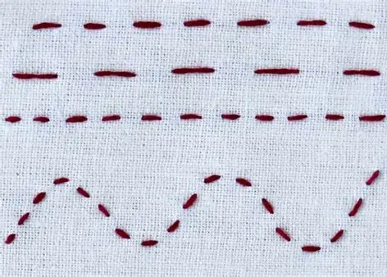
What you already know:

- You already know how to weave.
- You already know how to join various materials together using different media such as glue.
Key vocabulary
Thread
Needle
Sew
Fabric
Attach
Running stitch.
Cross stitch

Threading Stockings - Year 2
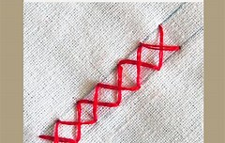

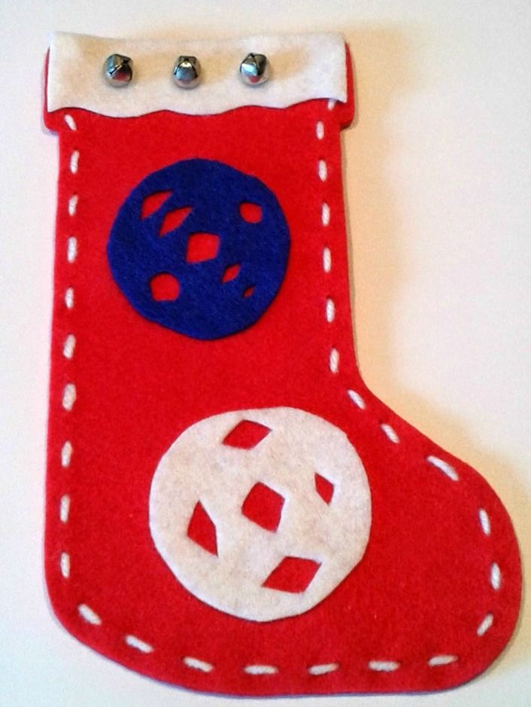
What you will be able to do by the end of the topic:

- know that there are different stitches you can use when sewing.
- know that sewing can make patterns as well as join fabrics.
- know basic vocabulary such as: needle, thread, running stitch, cross stitch
- thread a needle
- do running stitch
- use and apply these stitches to help create a stocking.

