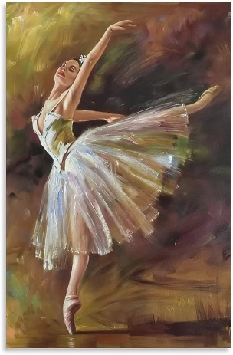
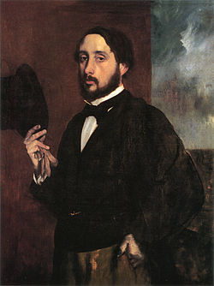
Edgar Degas-Year 2-Art-Drawing
What you will already know:
➢ You will know how to draw using pencils/crayons. ➢ You will know how to draw lines of different shapes and thickness using 2 different grades of pencil. ➢ You will be able to describe what you can see and like in the work of another. artist. ➢ You will be able to sensible questions about a piece of art. ➢ You will know how to recreate simple pieces of art from famous artists e.g. sunflowers- Van Gogh.
Key Vocabulary:
brighter, darker, shades, bold, outlines, patterns, observation, perspective, figures, charcoal.
What you will know by the end of this unit:
Drawing: You will be able to use drawing to develop and share your ideas, experiences and imagination exploring lines which are light/dark, hard/soft, straight/wavy/bumpy etc. You will develop a wide range of art techniques in using colour, pattern, texture, line, shape, form and space. You will continue to experiment with mark making, using a variety of tools including pens, pencils and charcoal. You will be able to talk about mark-making with peers and teachers. You will be able to draw focusing on outlines/shapes, patterns/lines.
Knowledge of artist: You will know who the artist Edgar Dregas was, when he lived, what inspired him, the mood of his work and be able to discuss his style including his Ballerina figure drawings. You will know some work by Degas and comment on it. You will be able to compare similarities and differences in his work.
Analysing works: You will be able to analyse different artistic styles in order to gain a wide understanding and sympathy with art. You will begin to comment on your own likes and dislikes and compare Degas with LS Lowry and other artists’ work. You will be able to recognise and discuss the techniques and media used to create artwork.

