Design and Technology - Year 2 Term 3
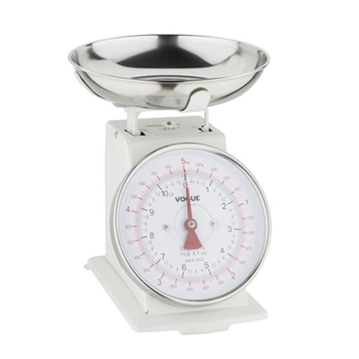
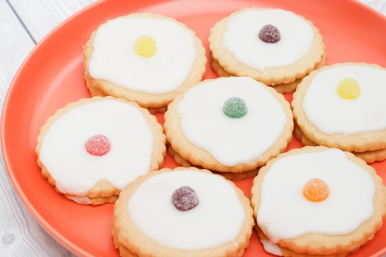
Making Short bread Biscuits
What you will already know:
➢ You will be able to tell someone about your design. ➢ You will be able to discuss in some detail what you like and don’t like about products you have created. ➢ You will be able to name foods from each section of the Eat Well plate.
What you will know by the end of this unit:
Design – You will be able to create a labelled drawing of your biscuit ideas. You will be able to use IT to explore and research their design ideas.
Make – You will be able read simple scales to help weigh ingredients before using/following the correct tools and instructions to help make biscuits.
Evaluate – You will be able to say what you like and do not like about your biscuit. You will be able to say how well their designs and product met the given design criteria (appealing, taste).
Key Vocabulary:
Design Plan Make Evaluate Label Scales Ingredients Weigh Cut
Mix Roll Bake

