Beech Class Term 3 Newsletter
Thank you for all your support last term from our parents and carers – our Nativity was a lovely way to showcase how hard the children have worked. We would also like to say thank you for the many gifts and cards we received in Beech Class.
We hope you all had a wonderful Christmas and a very Happy New Year!


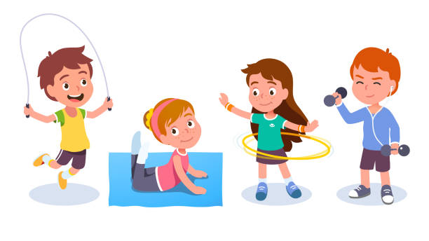
TERM THREE - Key information
PE every Friday afternoon, children should wear their PE kits to school. Our PE this term will be gymnastics.
Miss Wright to teach alternate Thursdays.

Reading Books: All pupils will have a reading record book, this is to keep track of the reading they do both at school and home. Please feel free to write extra comments in your child’s reading book should you like to, which I will keep track of. Every read at home will be rewarded with two house points. Reading records and reading books are collected every day.
Homework and spellings: These will be sent out each Thursday for you to help your child with. Homework is due the following Wednesday. Homework Club is run on a Wednesday during lunchtime for anyone who has not completed their homework.
How to get in touch: I will be available on the gate at the end of each day if you would like a quick chat about anything, or you can arrange an appointment via the office if you require. Throughout the year, there will be parent’s evenings, celebration of learning events as well as other events.
How you can help your child at home:
• Listen to them read, ask them questions about what they have read to check their comprehension.
• Team read – take turns in spending time reading a page each of their favourite book.
• Encourage them to engage with their homework and also learn their spellings each week. Sometimes our spellings may repeat to teach the children fluency and a deeper understanding of the spelling rules.
Kind regards,
Miss Harris

