Year 2 Route Explorers
Key vocabulary
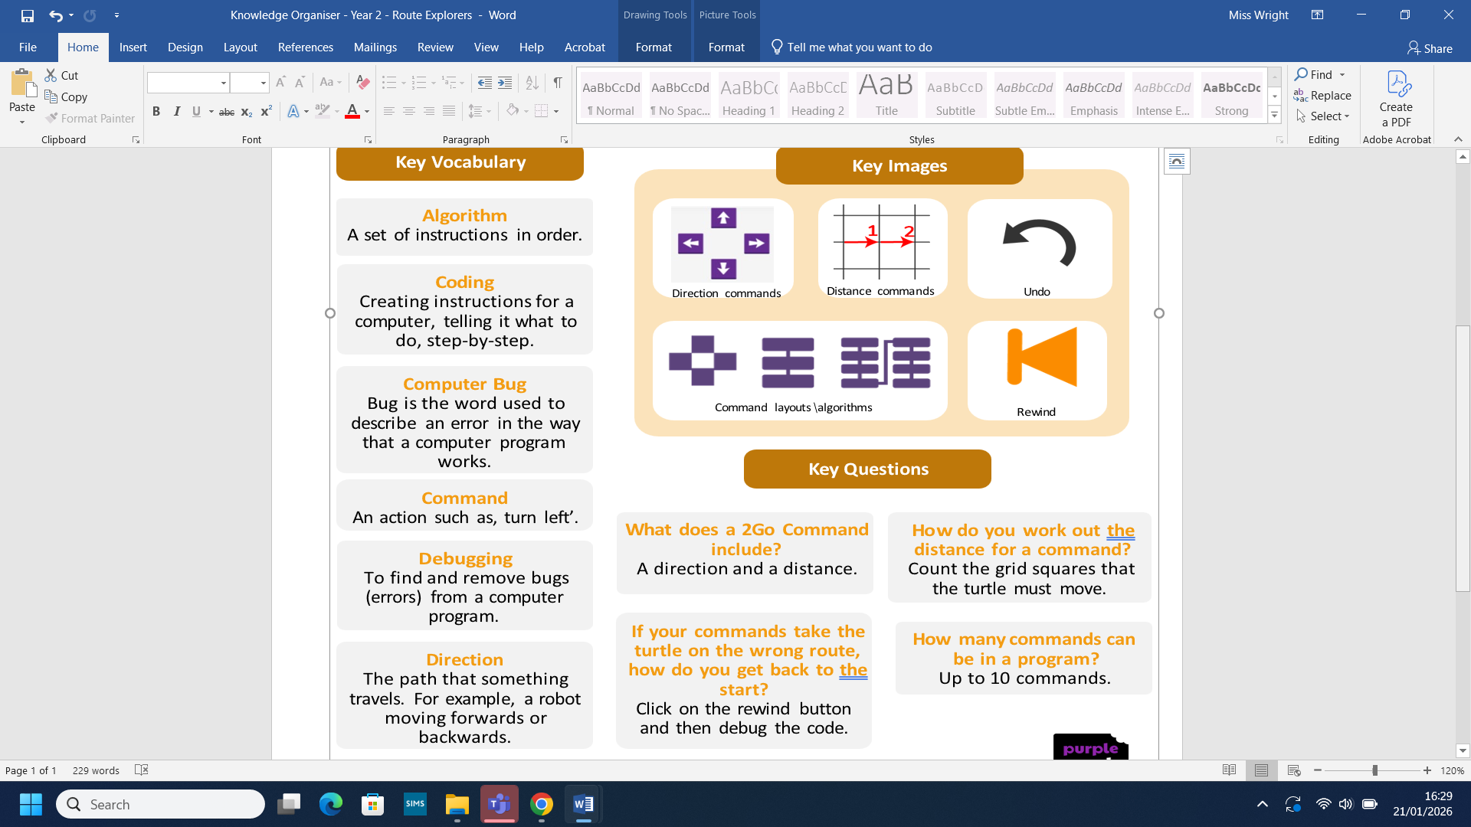
What we already know:
- You know how to use arrow keys.
- You will have used floor robots.
- You understand that an algorithm is a set of instructions.
- You can follow and create simple instructions on a device.
- You can sequence algorithms that require a correct order.

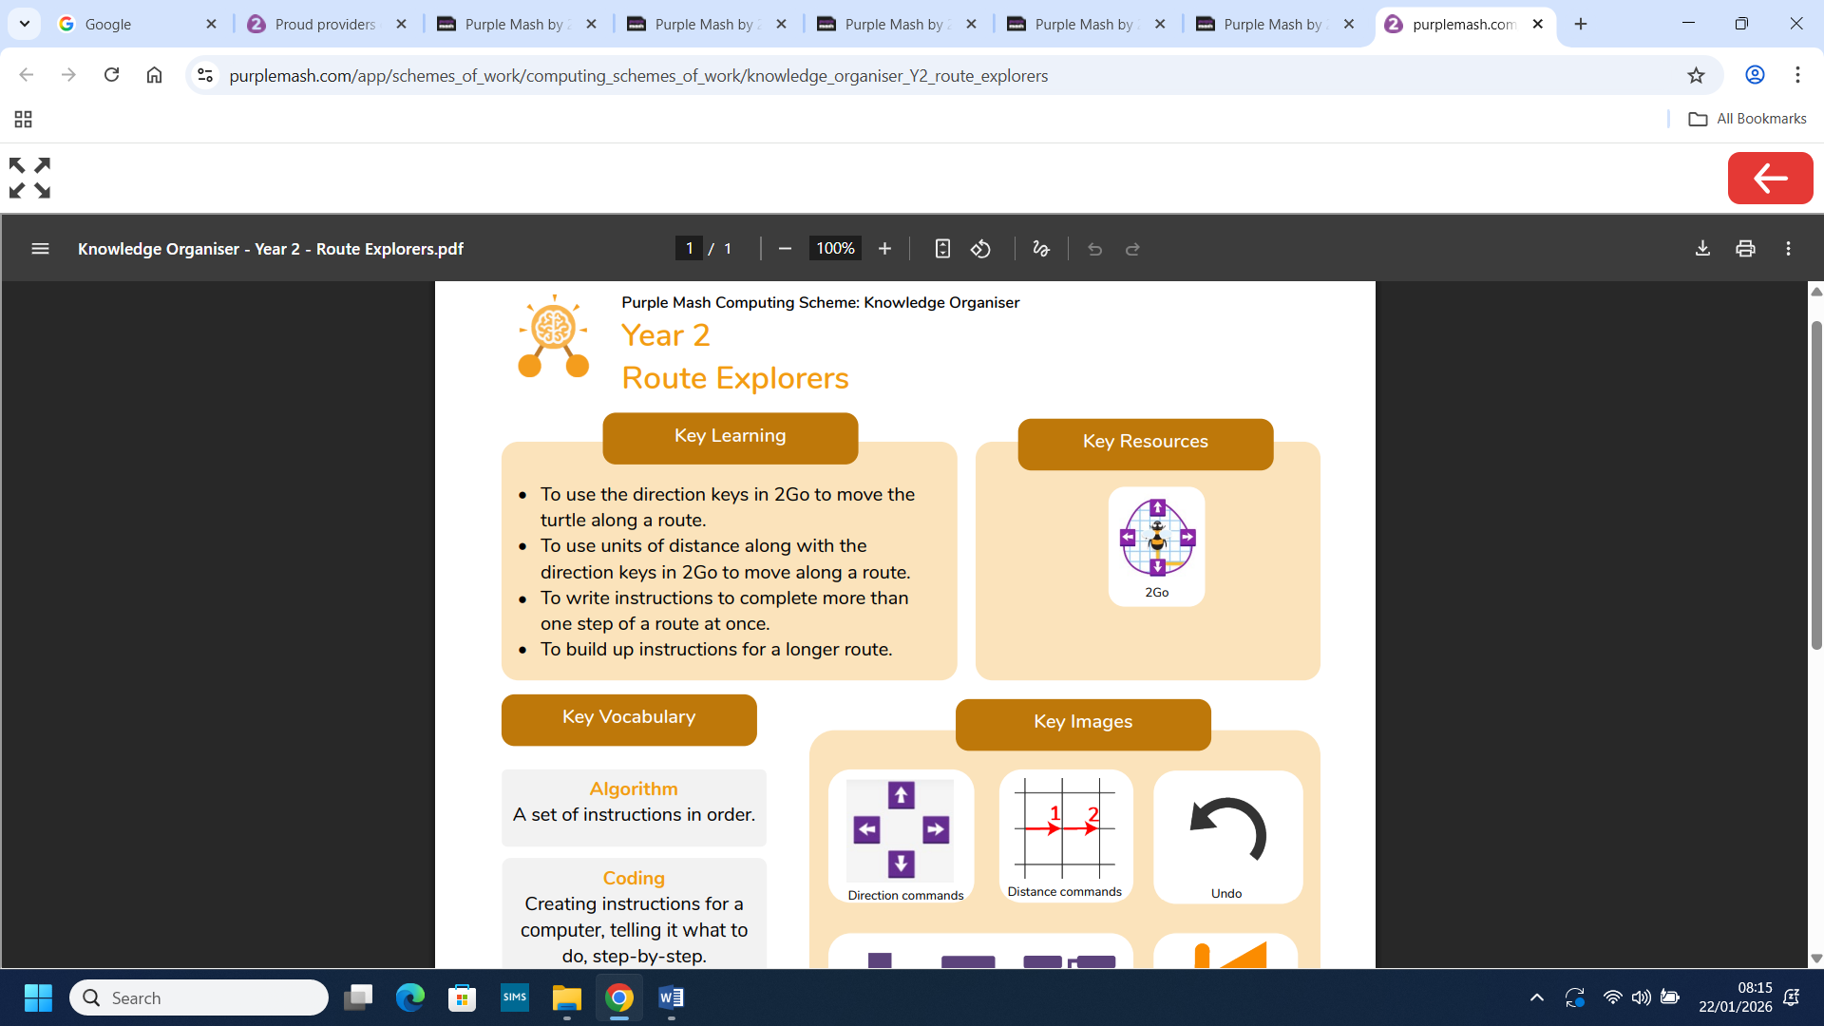

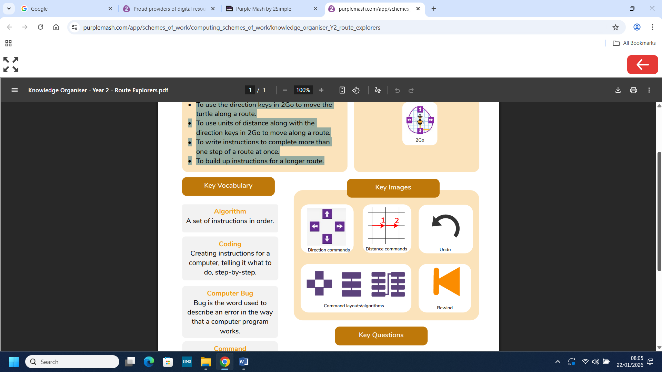
What we will know by the end of this unit:

- You will use the direction keys in 2Go to move the turtle along a route.
- You will use units of distance along with the direction keys in 2Go to move along a route.
- You will write instructions to complete more than one step of a route at once.
- You will build up instructions for a longer route.

