Key vocabulary
Air resistance – a type of friction between air and another material.
Force – strength or energy as a result of movement.
Force meter – used to measure forces. It is also known as a newton meter.
Friction – the resistance of motion, when one object rubs against another.
Gears – wheels with teeth that slot together. When one gear is turned, the other gear turns too.
Lever – helps us lift loads with less effort.
Mechanisms – a system of parts working together.
Pulleys – a simple machine comprising of a wheel on a fixed axle with a groove along the edges to guide a cable or rope.
Water resistance – is a force that slows things down that are moving through water.

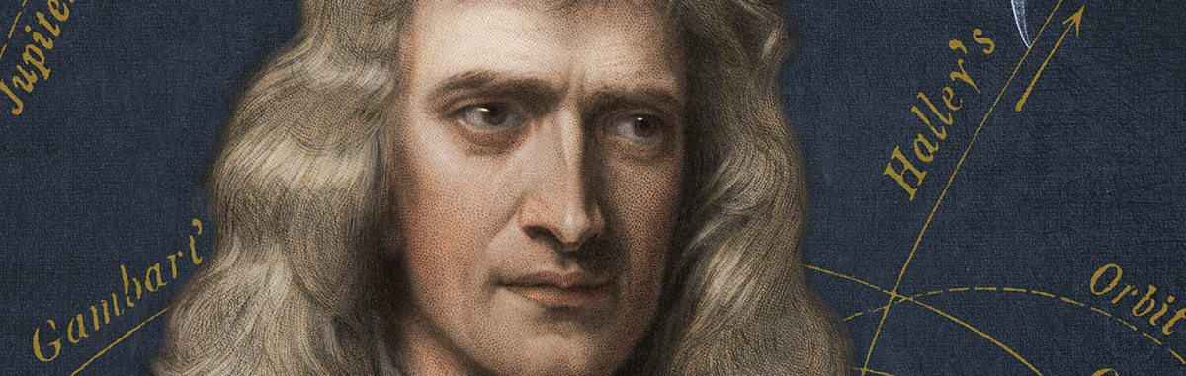

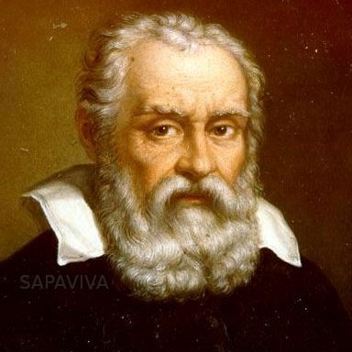
Forces - Yr 5/6

Isaac Newton

Galileo Galilei

What you already know:
Identifying different types of forces such as air resistance, water resistance and friction.
Compare how things move on different surfaces.
Notice that some forces need contact between two objects but magnetic forces can act at a distance.
Observe how magnets attract or repel each other and attract some materials and not others.
Describe magnets as having two poles and predict whether two magnets will attract or repel each other, depending upon which poles are facing.
Explore the strengths of different magnets and find a fair way to compare them.
Explore properties of magnets in everyday and suggest uses for them.

What you will know by the end of the topic:
Understand and explain that unsupported objects fall towards the earth due to the force of gravity acting between the earth and the falling object.
They may also find out about key scientists such as Galileo Galilei or Isaac Newton and how they contributed to the theories of gravity.
Identify the effects of air resistance, water resistance and friction that act between moving surfaces.
Recognise that some mechanisms including pulleys, levers and gears allow a smaller force to have a greater effect.
Use scientific enquiry skills to investigate forces.



