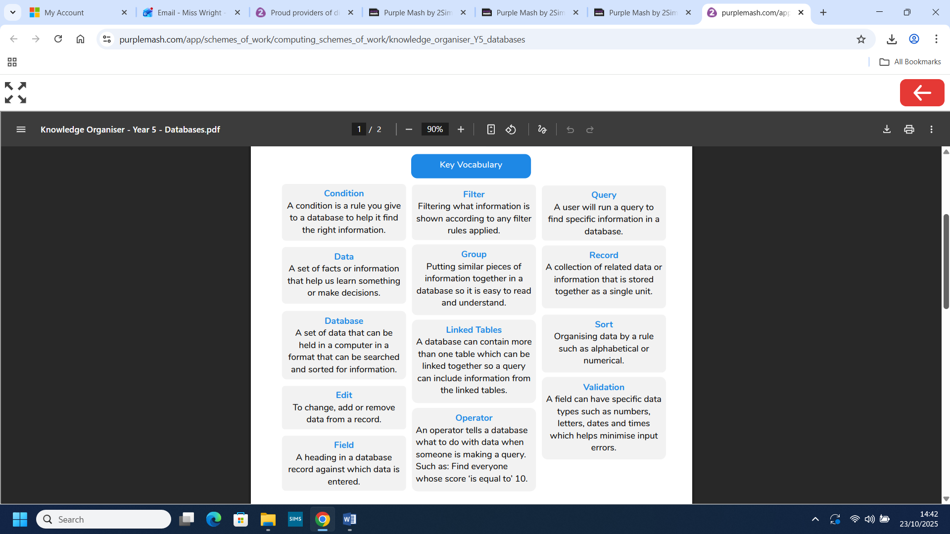
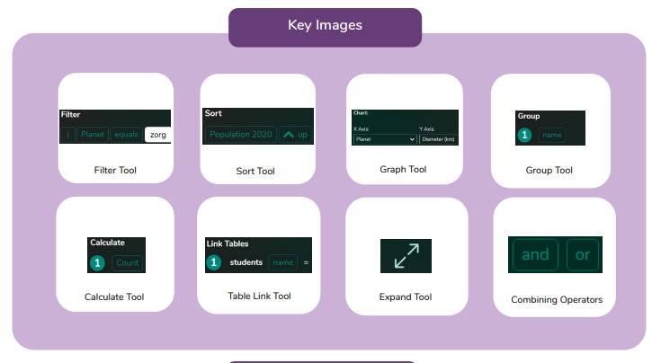
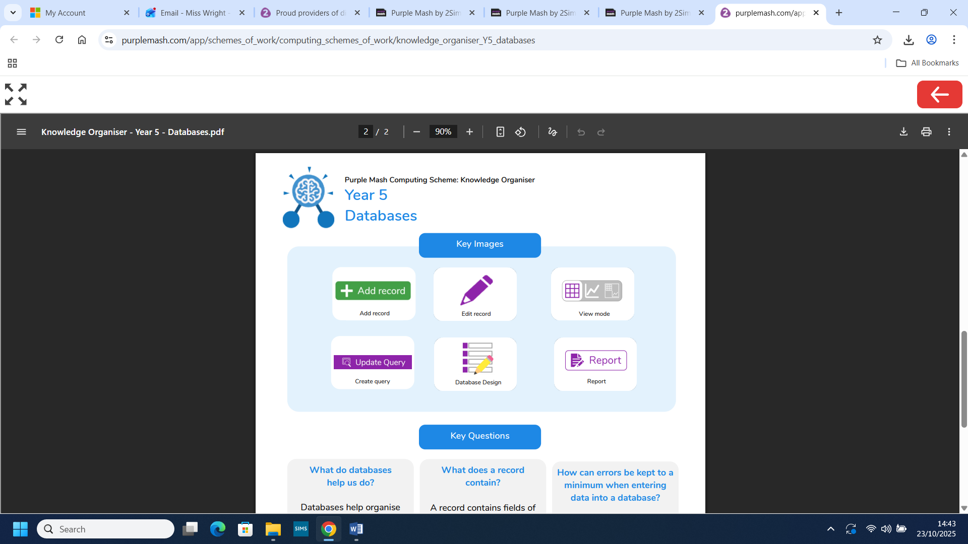
Computing: Databases and Data detectives
What you already know:
I understand the concept of using 'Yes' or 'No' questions to sort objects.
I understand and use a branching database effectively.
I can plan and create a branching database.
I can test and debug branching databases to correct errors.

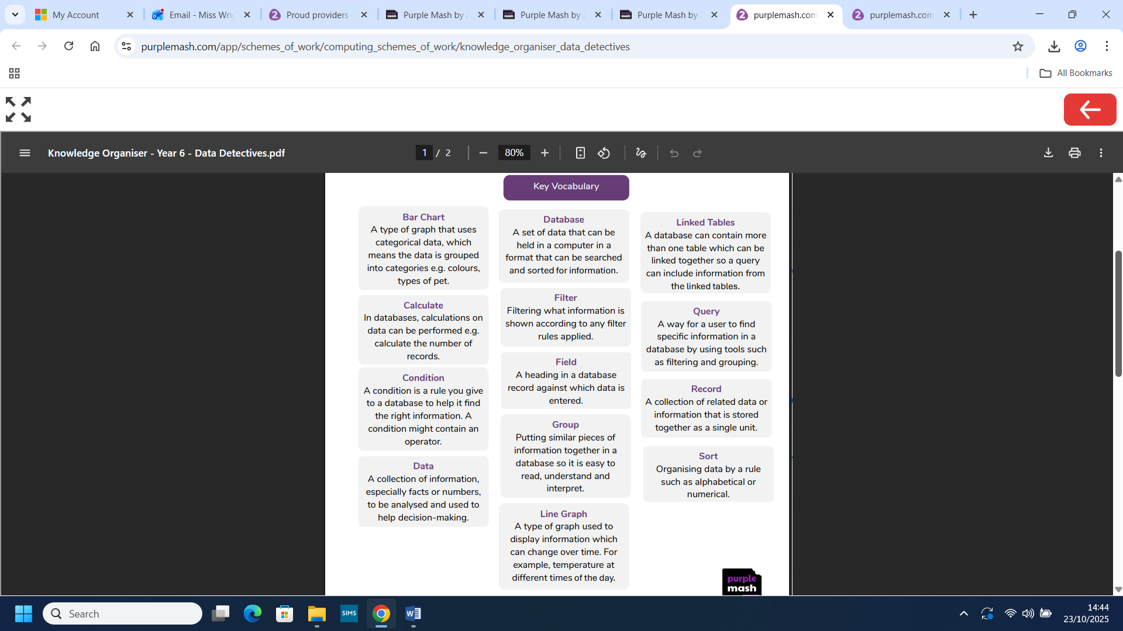
What you will know by the end of this unit:

I will understand what a database is.
I will design and create a database.
I will build queries to find information.
I will solve problems using a database.

I will find information in databases by filtering and sorting.
I will create graphs from data within a database.
I will be able to find information in linked table databases.
I will be able to find requested information using databases.

