What we will know/ be able to do by the end of this unit:
Design:
- Analyse and evaluate different car designs.
- Can select the appropriate materials to use. Identify design features of a car which enable it to move e.g. wheels and axle.
- Can create a labelled drawing of their idea and discuss it.
- Can use IT to explore, design and research their ideas.
Make:
- Can select from and use a range of tools and equipment to perform practical tasks to make their cars.
- Know and understand the steps that need to be followed to create the design.
- Can build structures, exploring how they can be made stronger, stiffer and more stable.
- Can make changes necessary if flaws are found.

Evaluate:
- Can say what they like and do not like about existing products.
- Can say how well their designs and product met the given design criteria (stable, does it move, do the wheels work).

What we already know/ can do:

Design:
- Can tell someone about their design.

- Can create a drawing of their idea and templates for design.

- Can use IT to explore design ideas eg research on internet for design ideas/ use a basic paint program to draw design.

Make
- Can use tape and glue to create temporary joins, fixed joins, moving joins.

- Use simple mechanisms in products eg hinges, levers, wheels

Evaluate
- Can say what they like and do not like about existing products.

- Can say how well their designs and product met the given design criteria.

DT making a moving car

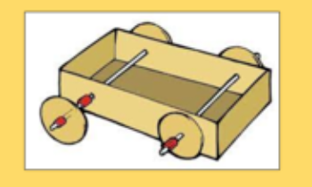

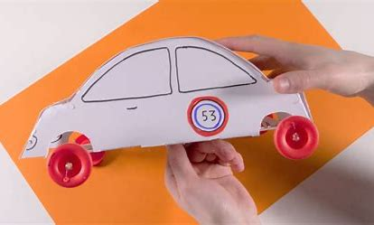

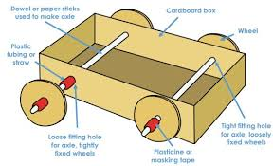
Vocabulary
Wheels Axel Join Design

Plan Make Evaluate Label

Improvements Materials Product Stiff

Stronger Stable Reinforce

