Key vocabulary
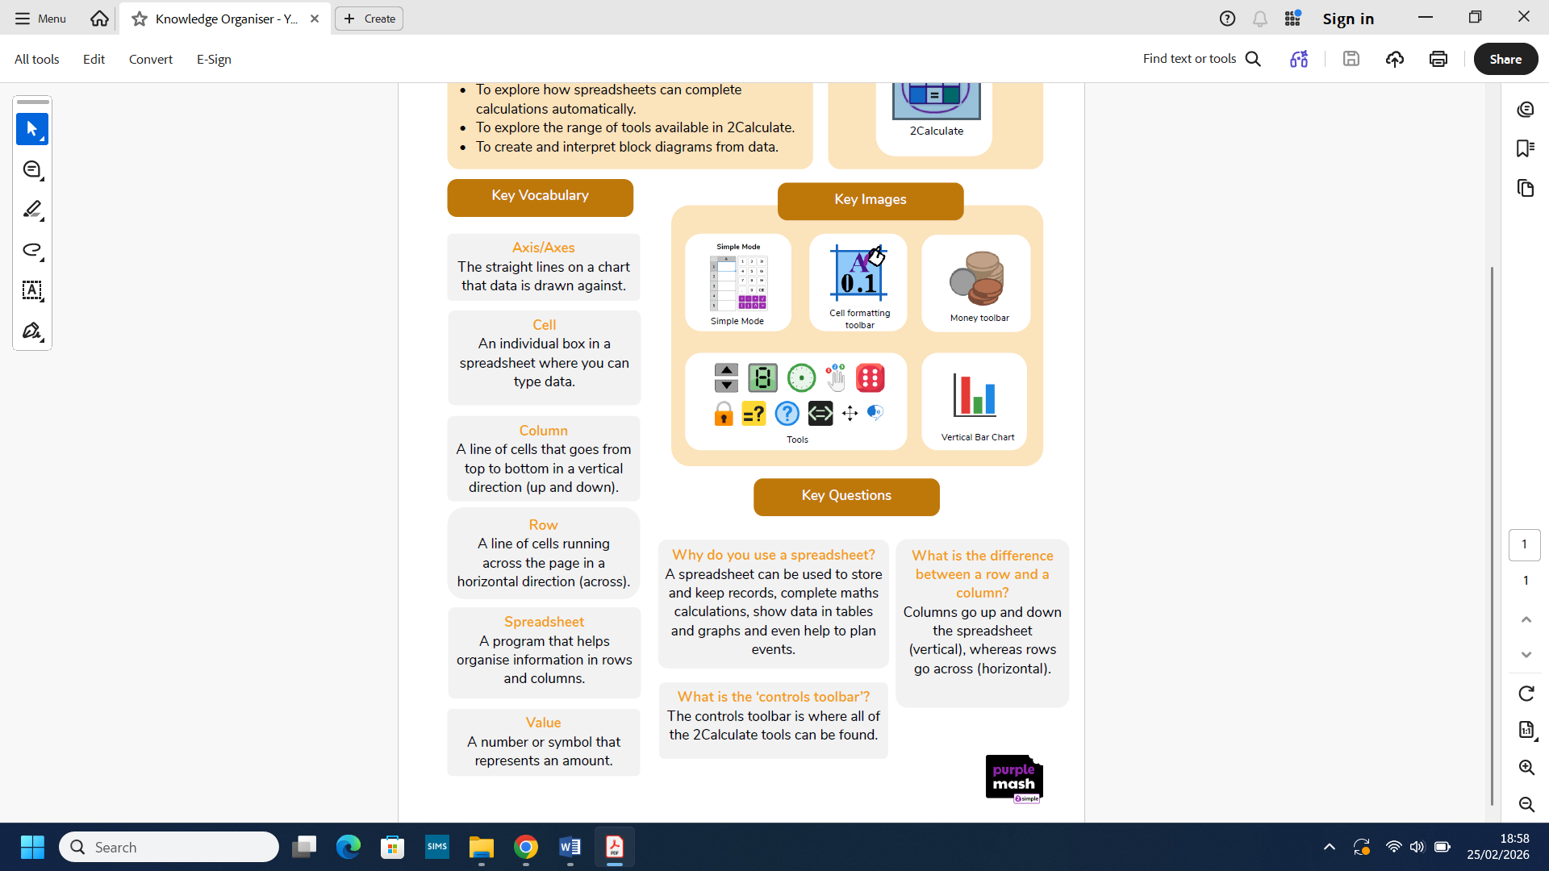
Year 2 Spreadsheets
What we already know:
- You can think carefully about the steps of grouping items.
- You can group items using a computer.
- You are able to sort different items.
- You understand that data is information that can be collected and used.
- You understand that data can be shown using pictures.

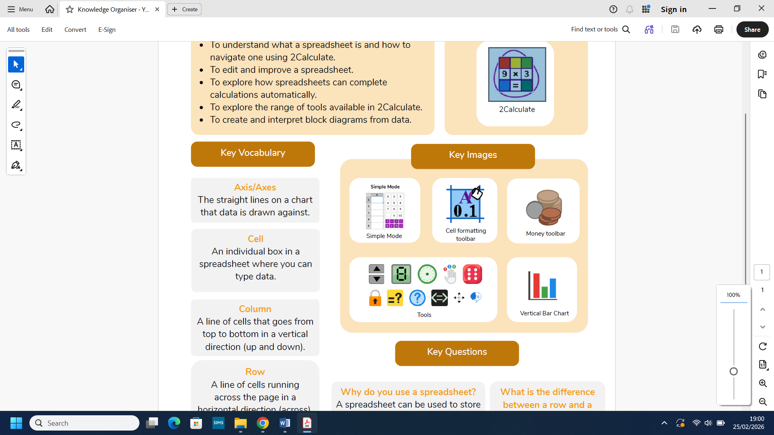
What we will know by the end of this unit:

- You will understand what a spreadsheet is and how to navigate one using 2Calculate.
- You will edit and improve a spreadsheet.
- You will explore how spreadsheets can complete calculations automatically.
- You will explore the range of tools available in 2Calculate.
- You will create and interpret block diagrams from data.

