What you already know:
We can identify and compare the suitability of a variety of materials for particular uses.
We know the materials – wood, metal, plastic, glass, brick, rock, paper, cardboard.
We can find how the shapes of solid objects made from some materials can be changed by squashing, bending, twisting and stretching.
We have looked at people who have developed new materials, such as Dunlop, McAdams and Mackintosh.
We can observe closely and use simple equipment.
We can perform simple tests.
We can identify and classify.

Key vocabulary
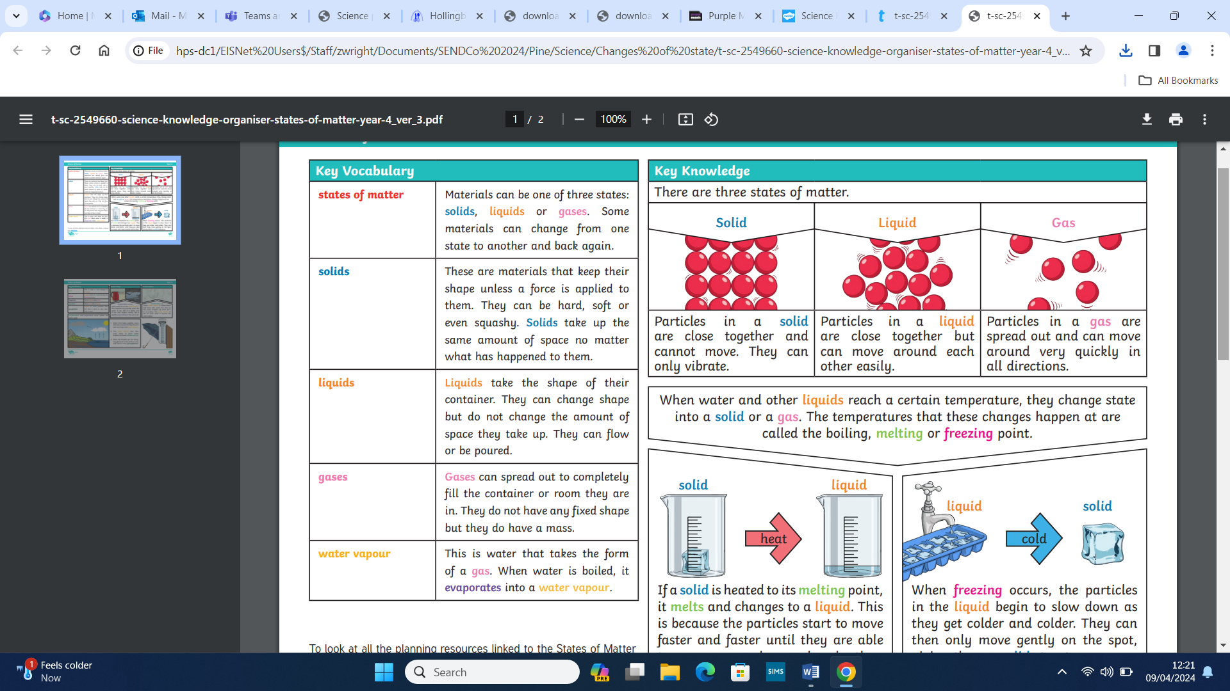
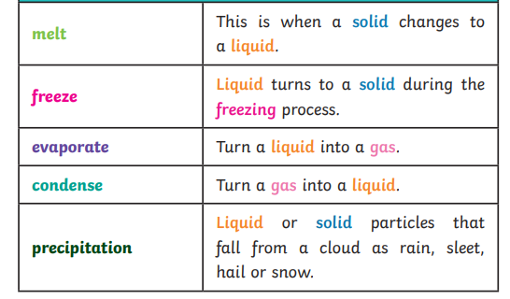
States of matter Y3/4

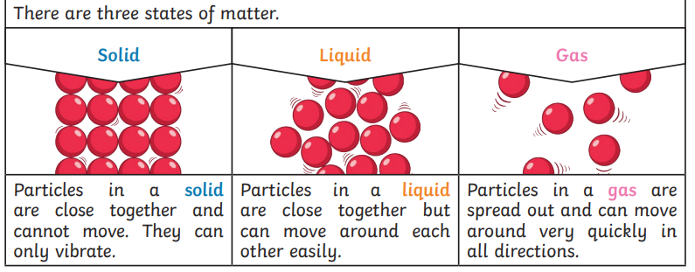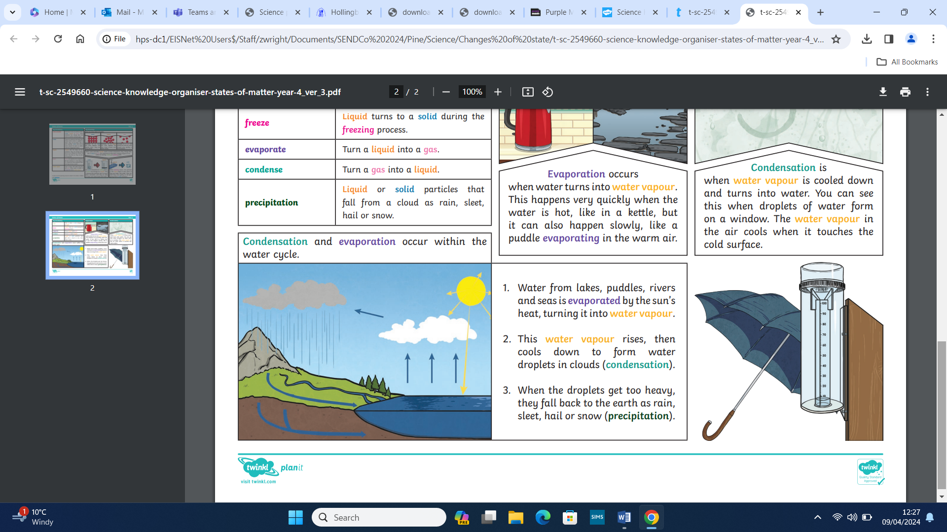

What you will know by the end of this unit:

We will be able to compare and group materials according to whether they are solids, liquids or gases.
We will observe that some materials change state when they are heated or cooled, and measure or research the temperature of when that happens (in degrees Celsius).
We will identify the part played by evaporation and condensation in the water cycle and associate the rate of evaporation of change with temperature.
We will make systematic and careful observations and, where appropriate, take accurate measurements using standard units, use a range of equipment, including thermometers.

