A shaduf is an ancient, hand-operated irrigation tool invented around 3000 BCE to lift water from the Nile for farming. Consisting of a long, pivoting, counterbalanced pole with a bucket, it efficiently raises about 20 litres of water to higher ground. It is still used today in parts of Egypt, India, and Africa.
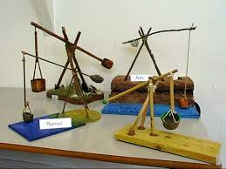

DT Shaduf - Yr 5/6

What you will know by the end of the topic:
You can research and understand what a shaduf was and how/why it was used.
You can design a shaduf using knowledge of mechanisms, materials and tools.
You can create a detailed diagram of your design and use this to create a prototype of your shaduf.
You can make a shaduf by selecting appropriate materials, tools, joints and mechanisms.
You can evaluate the design during the making stage, applying modifications when needed.
You are able to evaluate existing products in relation to their purpose and audience.
You can self evaluate the finished shaduf taking on board feedback from others on how it could have been improved.

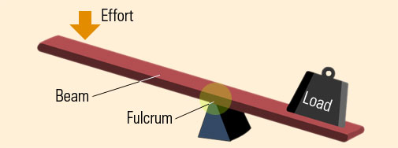
lever mechanism
What you already know:
You can recognise that some mechanisms including pulleys, levers and gears allow a smaller force to have a greater effect.
You have made these mechanisms during the Forces topic in Science.
You can generate and share ideas.

You can design, annotate sketches and use exploded diagrams e.g. magnify images .

You can use a range of materials and know how to strengthen and reinforce complex structures.

You can evaluate your finished product against their original design and suggest improvements.

Key vocabulary

Crops—plants grown on a farm.

Hand-operated—operated or controlled by hand.

Irrigation—supplying water to land by man-made means.

Lever – helps us lift loads with less effort.

Machine—an object with a system of parts that work together to perform a task.

Mechanisms – a system of parts working together.

Pivot—a rod or pin which another part rotates, swings or moves back and forth.

