What you already know:
- You have participated in listening walks and identifying sounds.
- You can distinguish between different types of sounds and be able to describe them, for example, plane, train, car, tractors as well sounds of nature.
Sound Y3/4
Key vocabulary
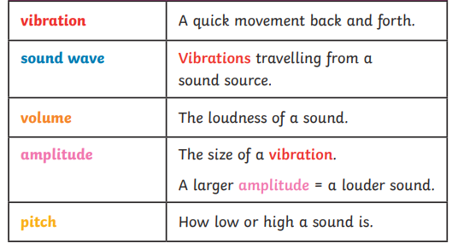
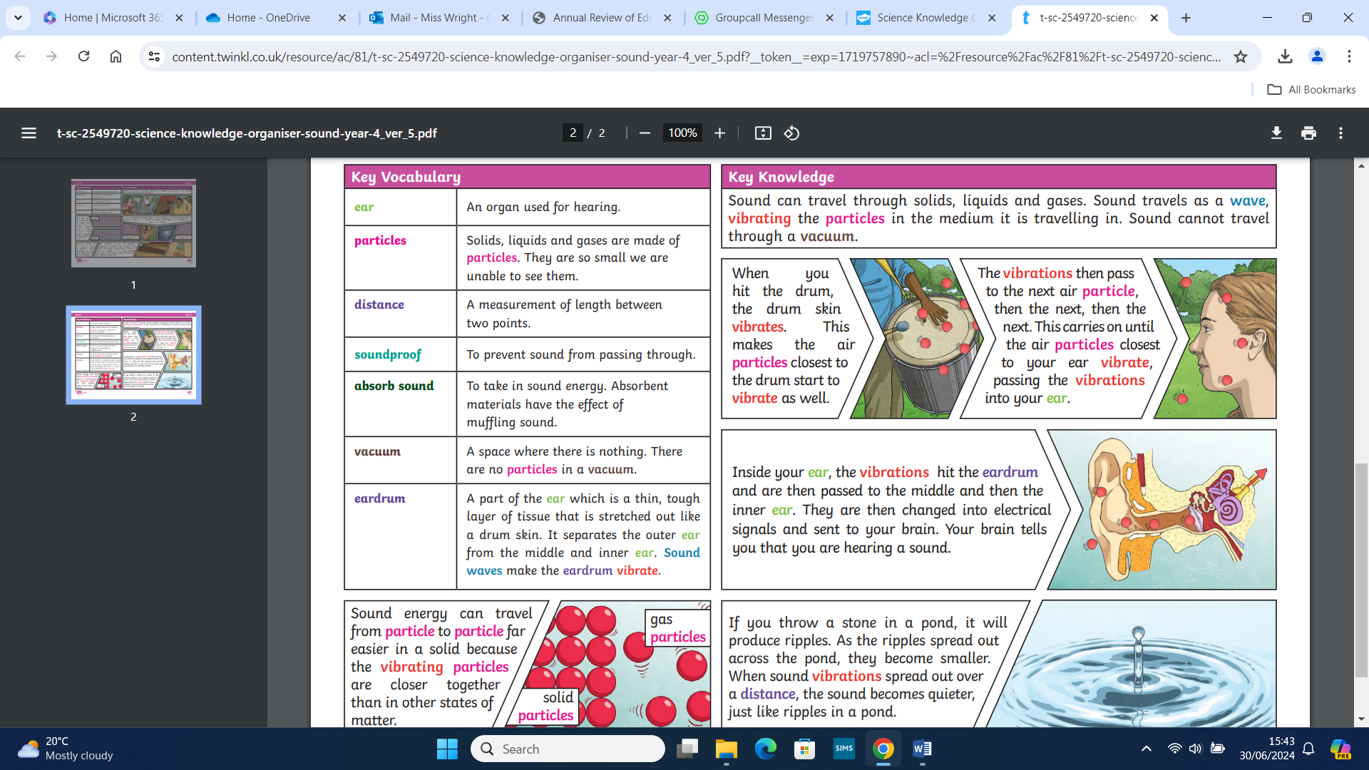

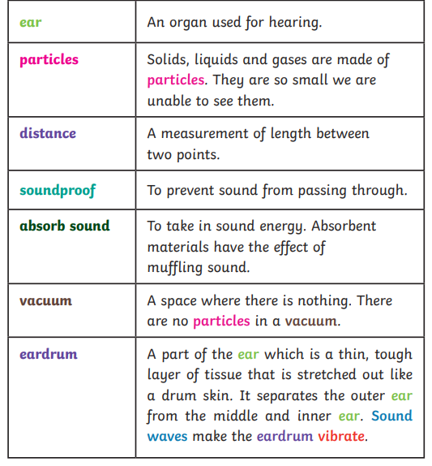

What you will know by the end of this unit:

- You will identify how sounds are made, associating some of them with something vibrating.
- You will recognise that vibrations from sounds travel through a medium to the ear.
- You will find patterns between the pitch of sound and the features of the objects that produced it.
- You will find patterns between the volume of the sound and the strength of the vibrations that produced it.
- You will recognise that sounds get fainter as the distance from the sound source increases.

- You will make systematic and careful observations and use results to draw simple conclusions.



