Year 2 Coding
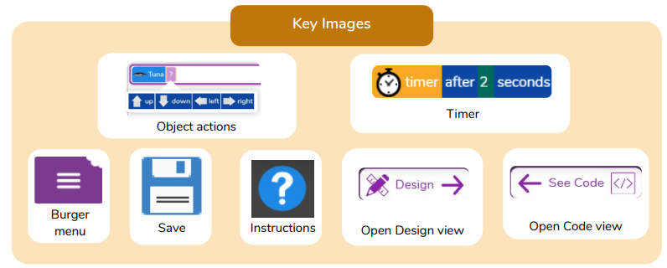
What we will know by the end of the unit:
- We can create a computer program using an algorithm.
- We understand ways that the collision detection event can be used in a program.
- We can design a program that follows a timed sequence.
- We understand that different objects have different attributes (properties).
- We understand the function of button objects in a program.
- We understand the importance of testing and debugging.

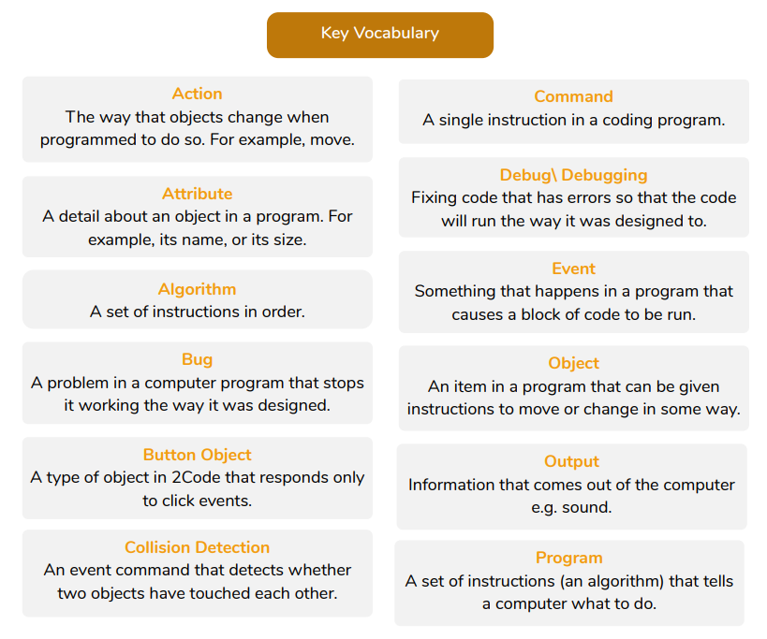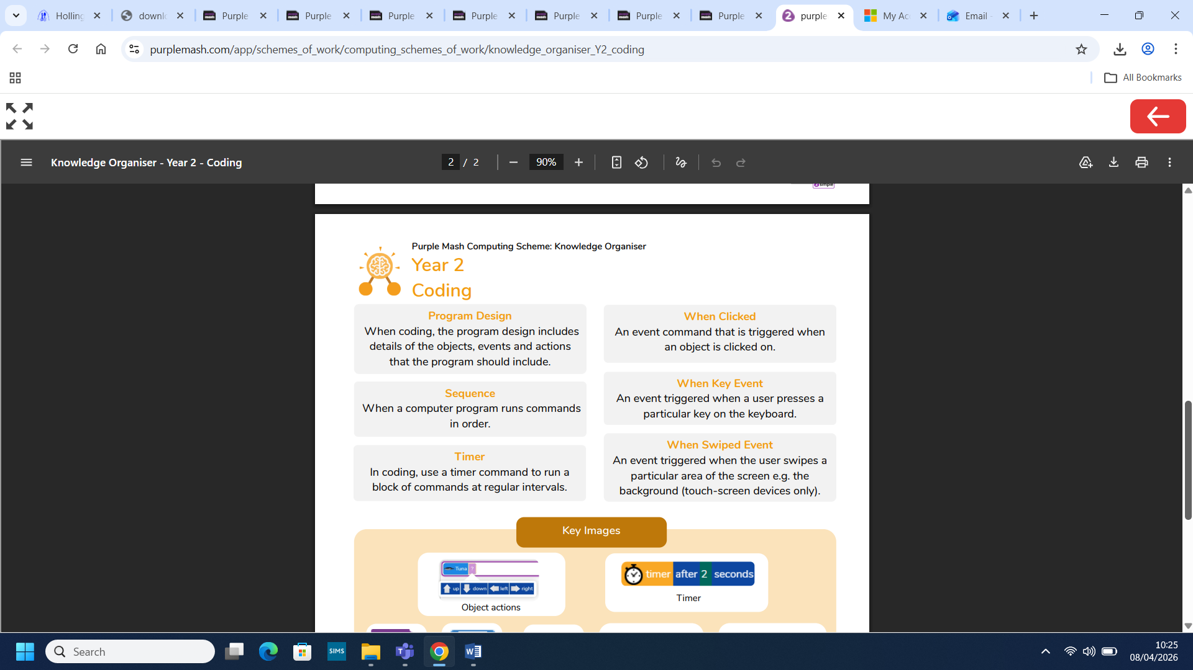
What we already know:
- We understand that computer programs work by following instructions called code.
- We can use object and action code blocks to make a computer program.
- We understand what an event is in coding.
- We understand the purpose of an output and to be able to ‘read’ code to find out what it does.
- We can change aspects of the design view.
- We can plan and make a computer program.

