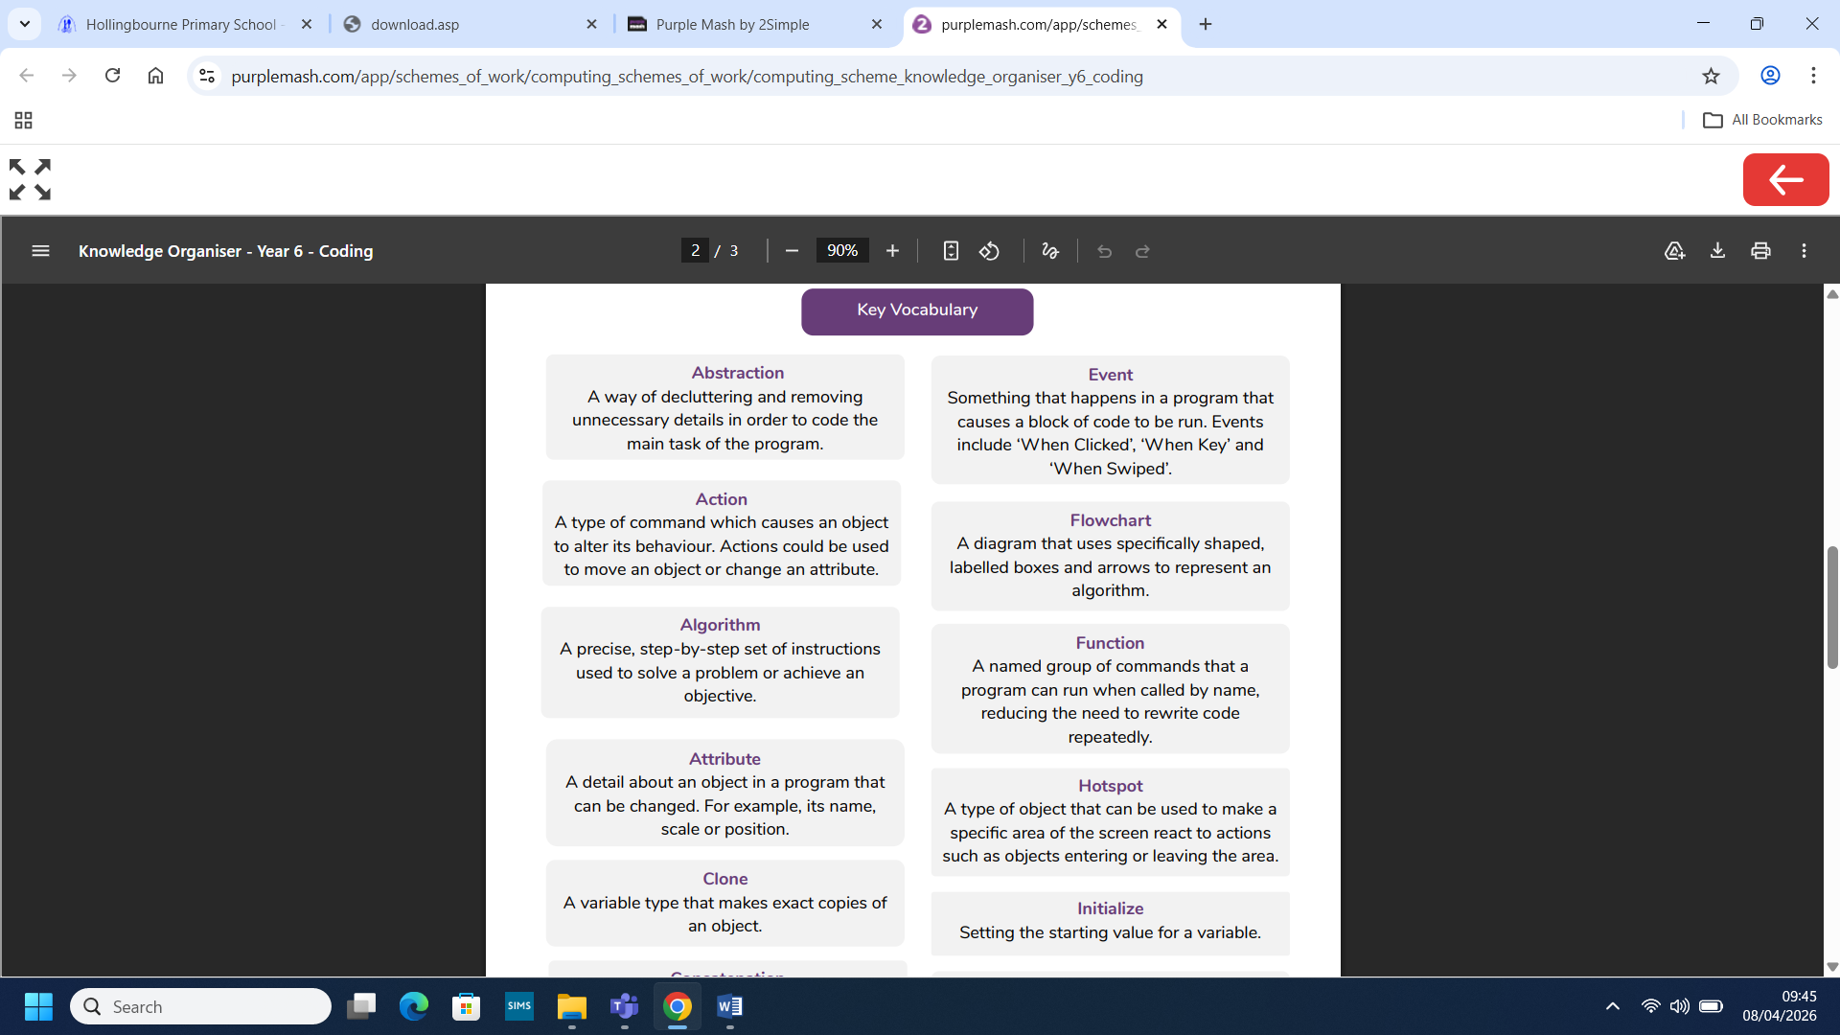
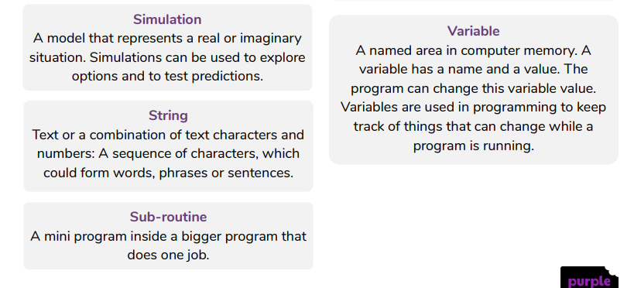
What you already know:
- To create a simple computer program using coding structures previously encountered.
- To know what selection means in computer programming.
- To know how to use co-ordinates in computer programming.
- To explore methods that introduce loops in coding.
- To understand what a variable is in programming.
- To create a game that keeps score.
You might also:
- To understand some ways that code can be simplified so that it is easier to read and runs more efficiently.
- To program a computer simulation using 2Code.
- To know what decomposition and abstraction are in Computer Science.
- To understand what a function is and how functions work in code.
- To understand what datatypes are and how they are used when coding with variables.
- To read code, predict outcomes and identify and fix bugs.

Computing: Coding 2
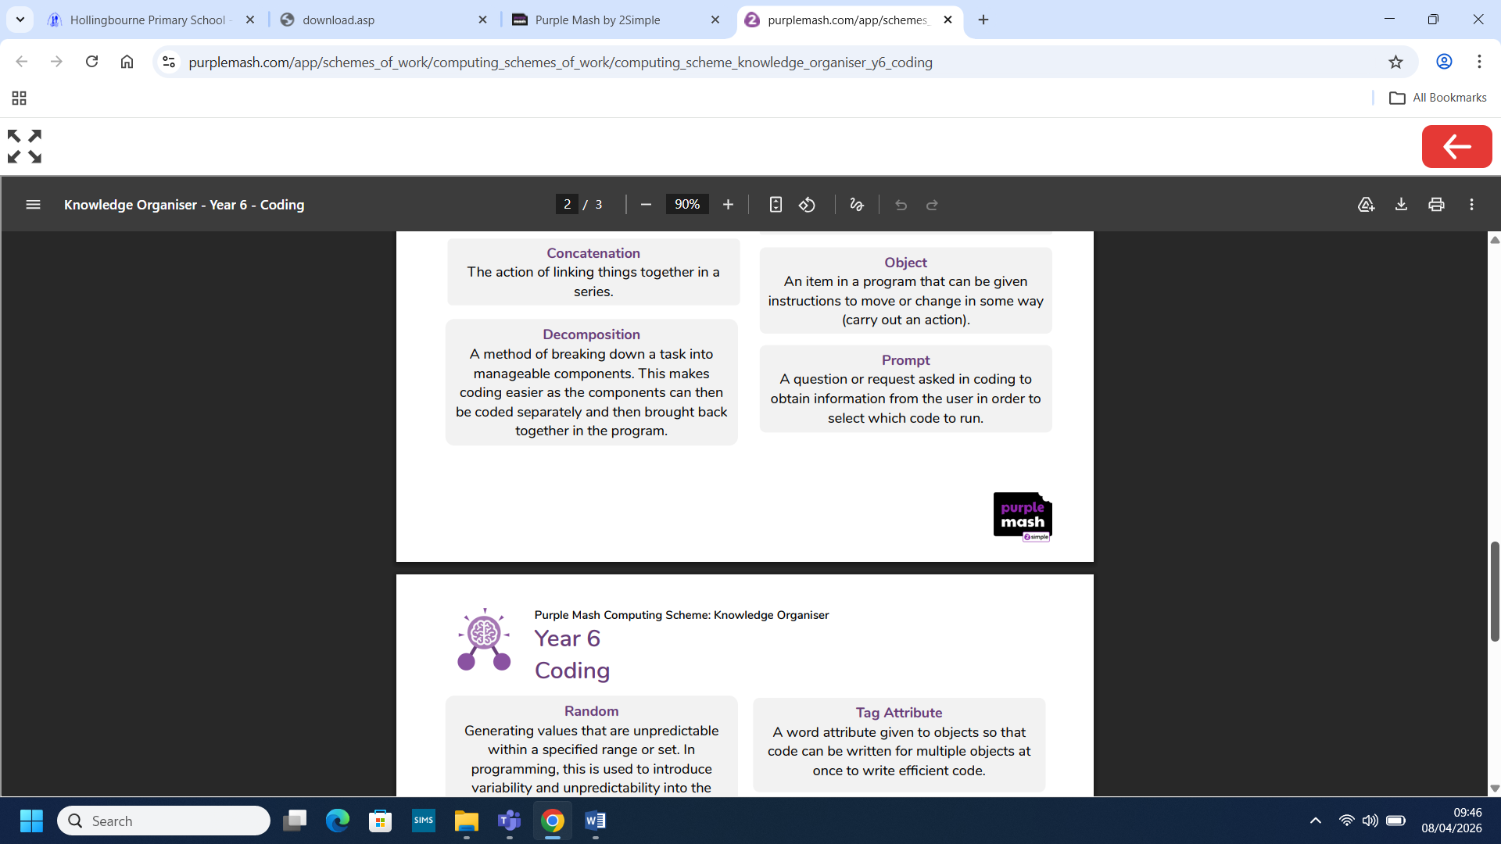
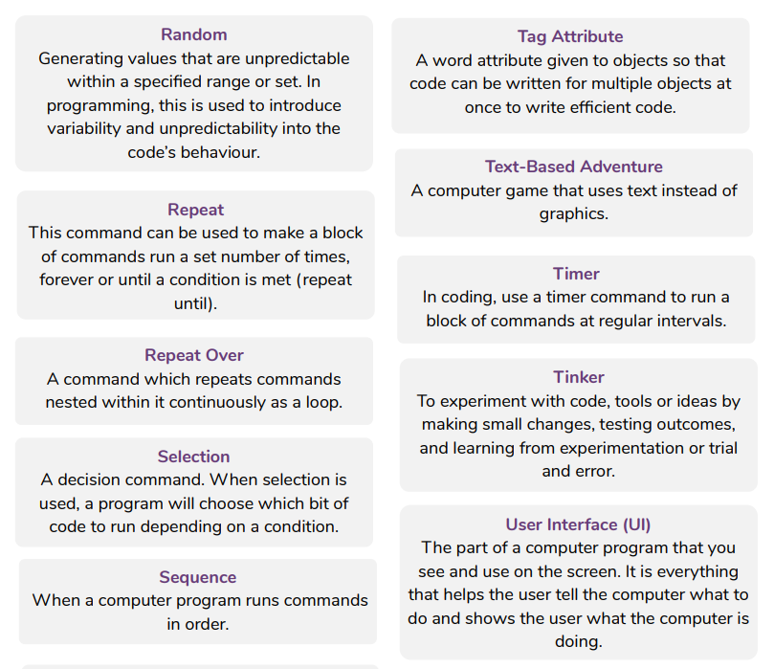
What you will know by the end of this unit:
- To understand ways to use cloning in 2Code.
- To explore the use of hotspots in 2Code.
- To understand the different options for generating and using user input in 2Code.
- To use flowcharts to test and debug a simulation.
- To use program design documentation to produce a program.
- To understand how 2Code can be used to make a text-based adventure game.

