What you will know by the end of the topic:
I will be able to associate the brightness of a lamp or the volume of a buzzer by the number and voltage of cells used in a circuit.
I will compare and give reasons for variations in how components function, including the brightness of bulbs, the loudness of buzzers and the on/off position of switches.
I will use recognised symbols when representing a simple circuit in a diagram.
I will construct series circuits to answer questions, including recognising and controlling variables where necessary.

Key vocabulary

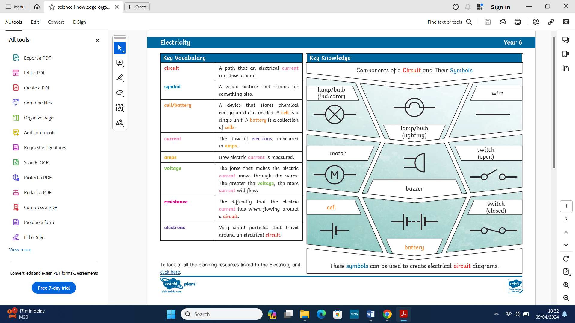

What you already know:
I can identify electrical appliances.
I am able to construct a simple series of electrical circuits.
I can identify cells, wires, bulbs, switches and buzzers.
I can identify if a circuit is a complete loop or not.
I know that a switch opens and closes a circuit and that this affects if the lamp is on.
I am able to recognise some common conductors and insulators.
I can associate metals with being good conductors.

Electricity - Yr 5/6

