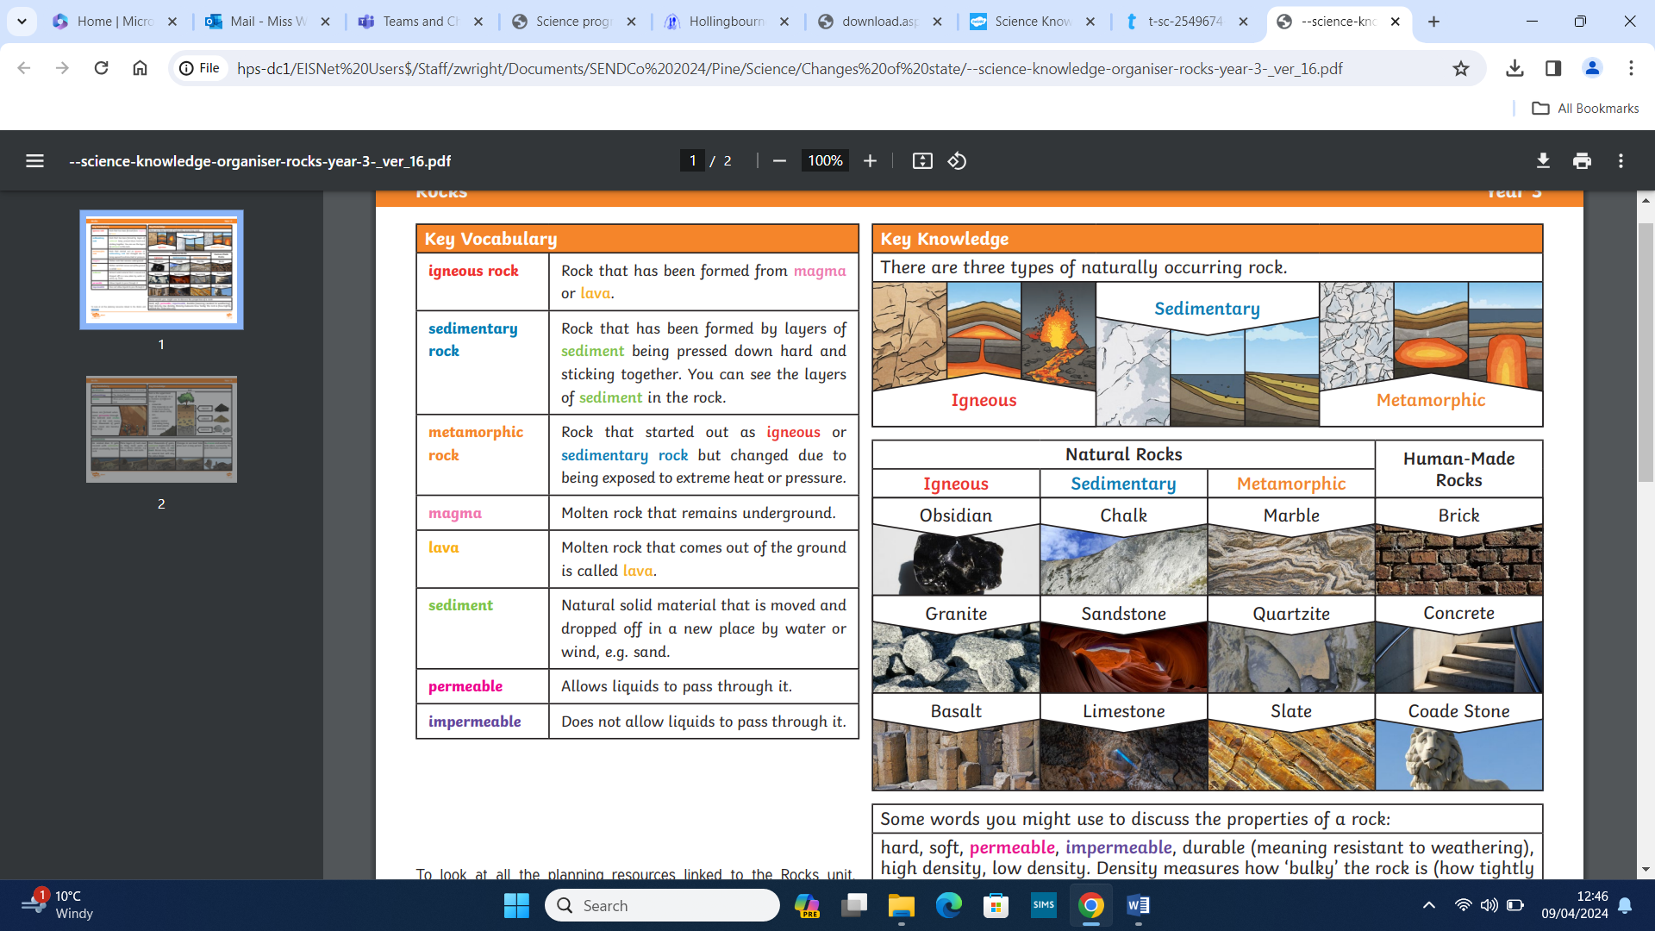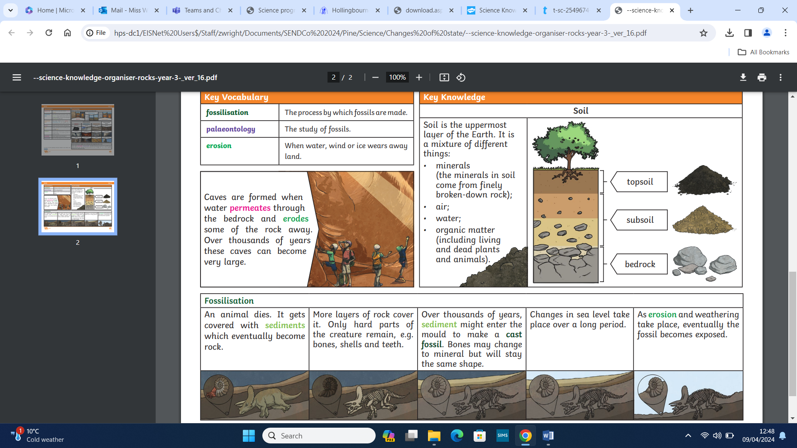

Key vocabulary
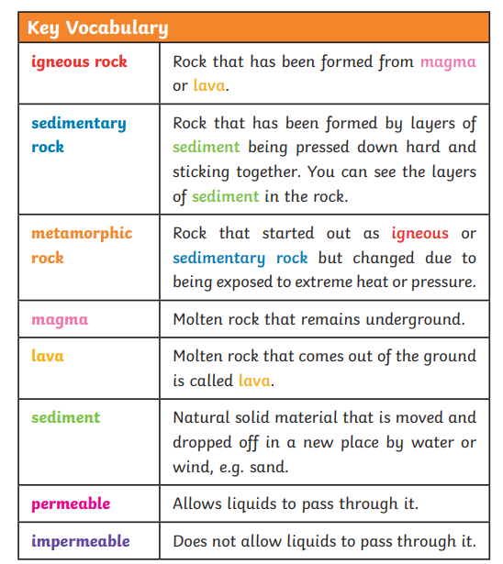

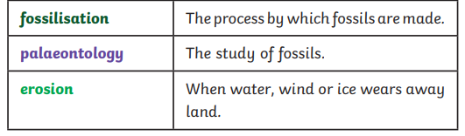
Rocks Y3/4

What you already know:
- You will have observed different types of rocks and soil.
- You will have heard of fossils.

What you will know by the end of this unit:

- You will compare and group different types of rocks based on appearance and physical properties.
- You will know how fossils are formed.
- You will be able to recognising that soil is made from rocks and organic matter.
- You will make systematic and careful observations.
- You will record, classify and present data in a variety of ways using scientific language accurately.



