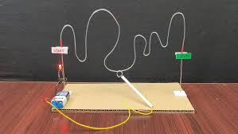

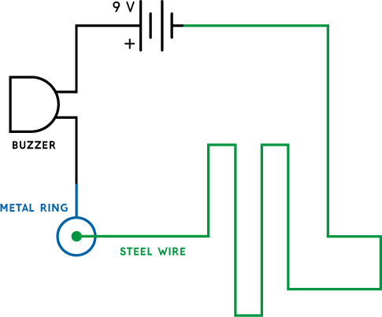
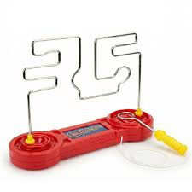
D.T/Science Buzz Games - Yr 5/6

What you already know:
Design
-You can generate, develop, model and communicate their ideas through discussion.
-You can design and make prototypes.
-You can use exploded diagrams.
-You can use research and develop design criteria to inform the design of innovative.
-You can design products that are functional and designed for purpose.
Make
-You can choose and use appropriate materials and equipment.
-You can measure, create structures and find ways to strengthening these.
Evaluate-
-You can evaluate ideas against their design and design brief.

Science
-You can construct series circuits and can control variables.
-You can recognise circuit symbols.

What you will know by the end of the topic:
Design
-You can use existing knowledge of electricity to design an appropriate circuit to operate a buzz game. This was represented in a circuit diagram.
-You can explore existing products and use ideas to design a buzz game that is innovative and appeals to individuals or groups.
-You can represent your design clearly and will include an exploded diagram.
-You can plan methodical steps to make our product.
Make
-You can apply your scientific knowledge and practical skills to assemble a working circuit, problem solving when required.
-You can identify, select and use a range of tools to help assemble the circuit and structure of game, for example, pliers, wire cutters, saws, sandpaper, drill, considering safety.
Evaluate
-Whilst creating design, you can recognise the need to modify your design accordingly.
-You can consider how to improve your design through both self-reflection and collecting feedback from others.
Key vocabulary

An exploded diagram shows parts of a produce separated, but in correct places for fitting together. They are useful for showing how different parts of a product will join together.
An electrical circuit is a complete, unbroken loop that electricity flows around to power a device.
Components are any basic part used in a circuit that uses electricity to make something happen E.g. a buzzer to make sound.
A cell is a single unit that stores chemical energy and changes it into electricity.
A battery is a team of two or more cells working together to give power.
A Switch controls the flow of electricity in a circuit. A gap can be created to stop the flow.
A drill is a spinning tool used to make holes.
A hacksaw is a small saw with fine teeth used to cut through hard materials.

