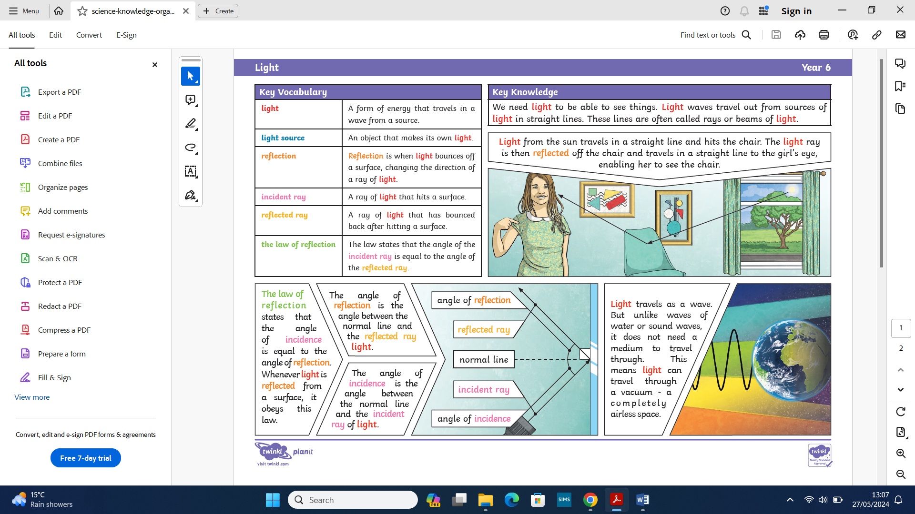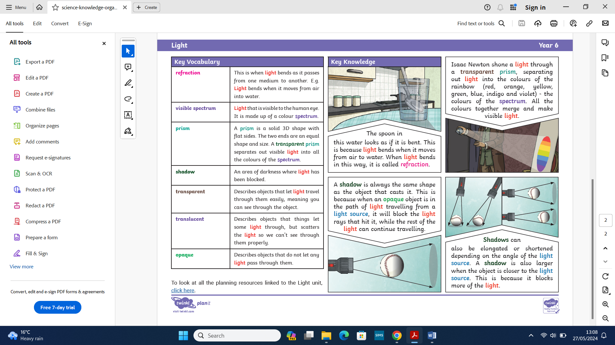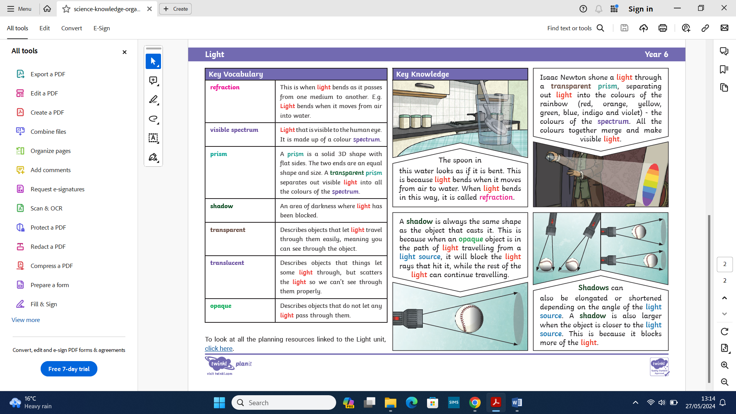
What you will know by the end of the topic:
- I can recognise that light appears to travel in straight lines.
- I can use the idea that light travels in straight lines to explain that objects are seen because they reflect light into the eye.
- I am able to explain that we see things as light travels from light sources to our eyes or from light sources to objects and then to our eyes.
- I can use the idea that light travels in straight lines to explain why shadows have the same shape as the objects that cast them.

- I can record results of increasing complexity using scientific diagrams and labels.
- I can plan an investigation to find out how shadows behave including recognising and controlling variables where necessary.
- I can report and present findings from enquiries, including conclusions, causal relationships and explanations.
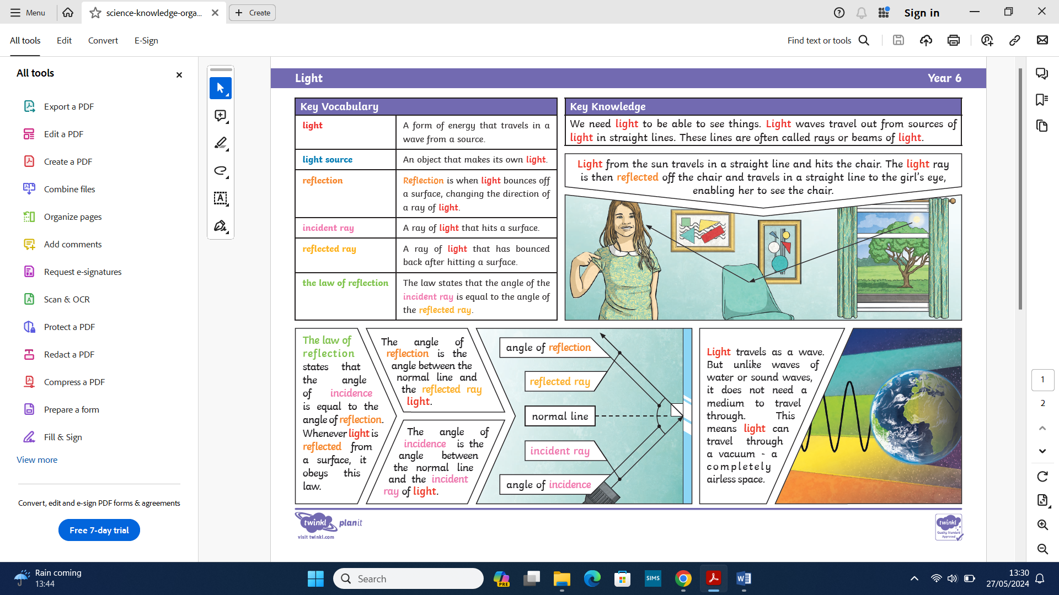
What you already know:
- I can recognise light is needed in order to see things and that dark is the absence of light.
- I can notice that light is reflected from surfaces.
- I know that sunlight is dangerous and eyes should be protected.
- I recognise shadows are formed when light from a light source is blocked by an opaque object.
- I am able to find patterns in the way the size of shadows change.
Light Yr 5/6

