Knowledge Organiser – Electricity
Many everyday appliances rely on electricity for them to work. Some appliances need to be plugged into a socket (mains electricity) and others have a battery to make them work.
Electricity can be generated from wind power used to turn windmills and hydroelectric power from water used in dams. The Sun’s rays can be converted into electricity by solar panels. Electricity is a form of energy that can be carried by wires and is used for heating and lighting, and to provide power for devices.

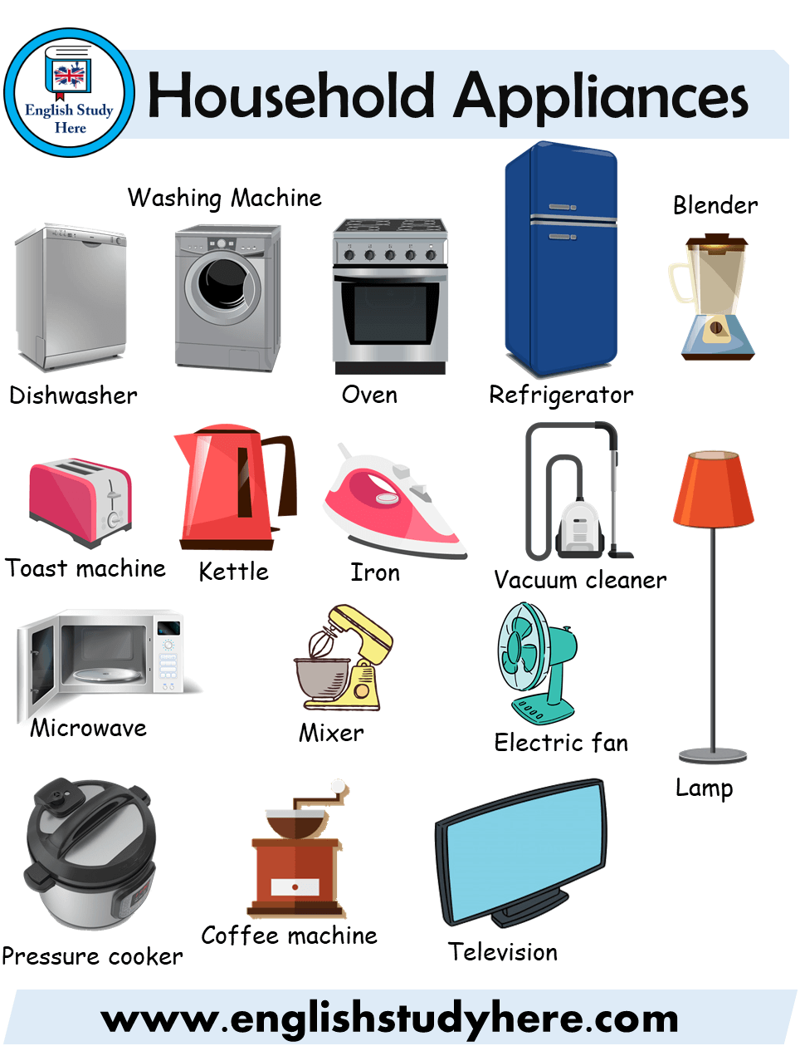

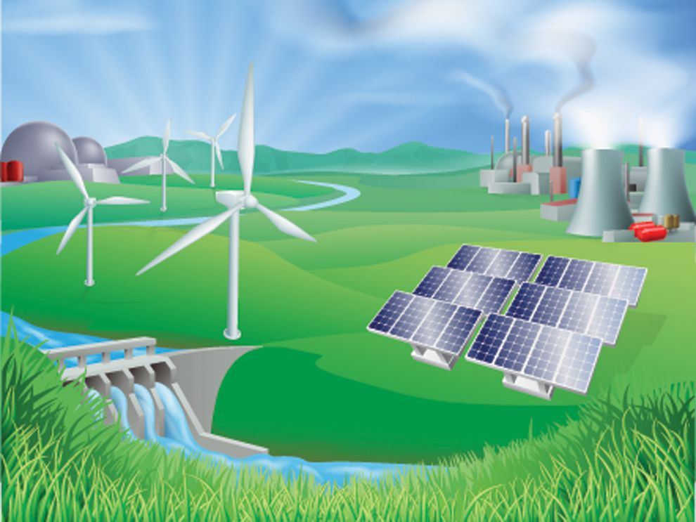

What I already know:
Children naturally encounter battery-powered toys or plug-in household devices.
What you will know at the end of this term
- You will identify electrical appliances.
- You will construct a simple series of electrical circuits, identifying and naming its basic components.
- You will identify if a circuit is a complete loop or not.
- You will know that a switch opens and closes a circuit and that this affects if the lamp is on.
- You will recognise some common conductors and insulators.
- You will work scientifically, making systematic and careful observations, gathering, reporting and presenting data and using results to draw simple conclusions.

Vocabulary

Cell: A device containing electrodes immersed in an electrolyte, used for generating current.
Battery: A container containing one or more cell.
Circuit: a complete route which an electric current can
flow around.
Electrical appliance: A device that uses electricity to perform a specific task.
Electrical conductor: A material that allows electricity to pass through it.
Electrical insulator: A material that stops electricity passing through it.
Electricity: The flow of an electric current or charge through a material.
Series circuit: An electrical circuit in which all components are connected end-to-end in a single path.

National Curriculum links and rationale Children will explore the 1960s to extend their chronological knowledge of British history to explore and understand aspects of life in more recent times. They will learn about fashions, music and entertainment.

