What you will know by the end of the topic:
- You will compare and group together materials based on properties including: hardness, solubility, transparency, conductivity (electrical and thermal) and response to magnets.

- You will give reasons for particular uses for everyday materials including metal, wood and plastic based on their own experiments and fair test.

- You will know some materials will dissolve to form a solution and you will be able to describe how to recover a substance from a solution.

- You will decide how mixtures can be separated by filtering, sieving and evaporating.

- You will be able to demonstrate that dissolving, mixing and changes of state are reversible.

- You will explain that some changes result in the formation of new materials and that this is not normally reversible.

- You might research chemists such as Spencer Silver and Ruth Benerito.
- Use scientific enquiry skills to investigate materials. We will plan a fair test, take repeated measurements, record and present accurately in a variety of ways and identify any casual relationships. We will fully reflect upon our findings including making predictions to set up further tests.

Properties and Changes of Materials
Yr 5/6
Key vocabulary
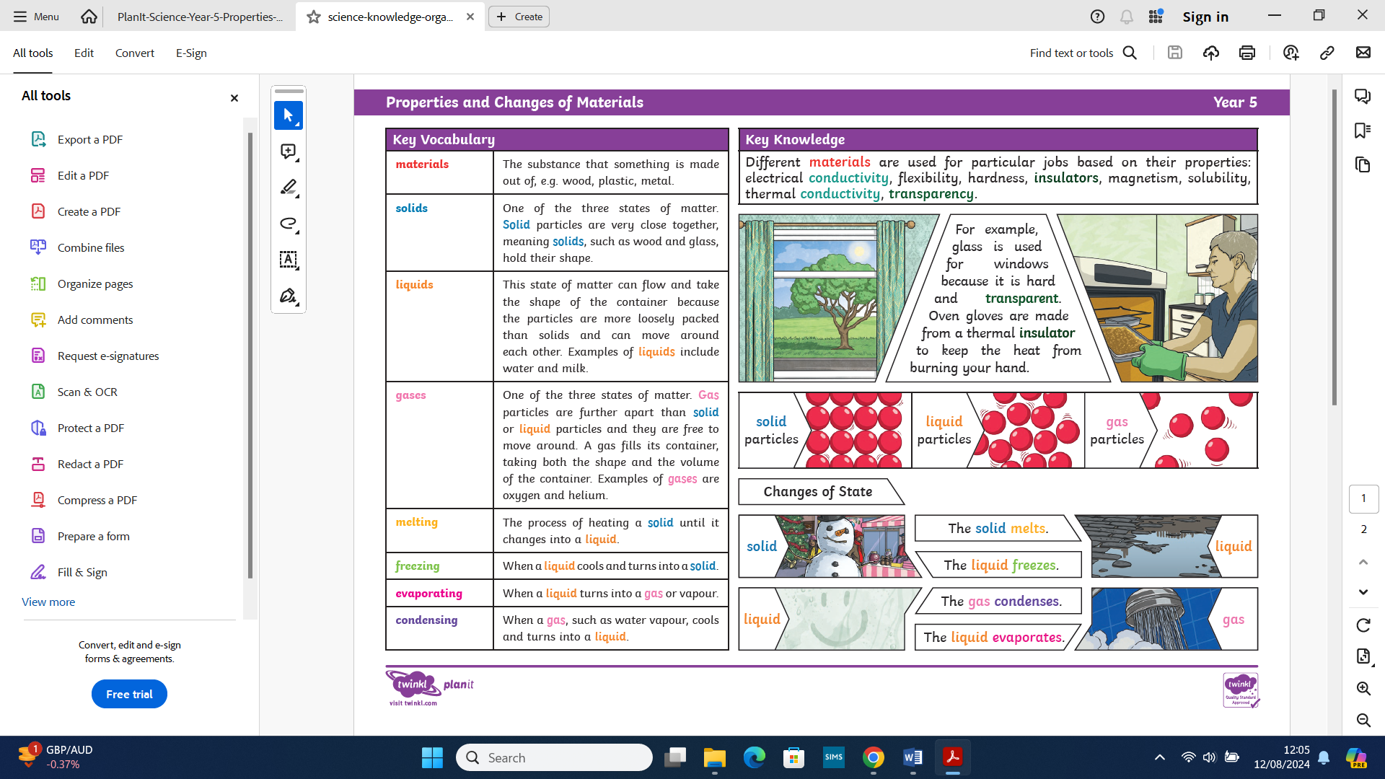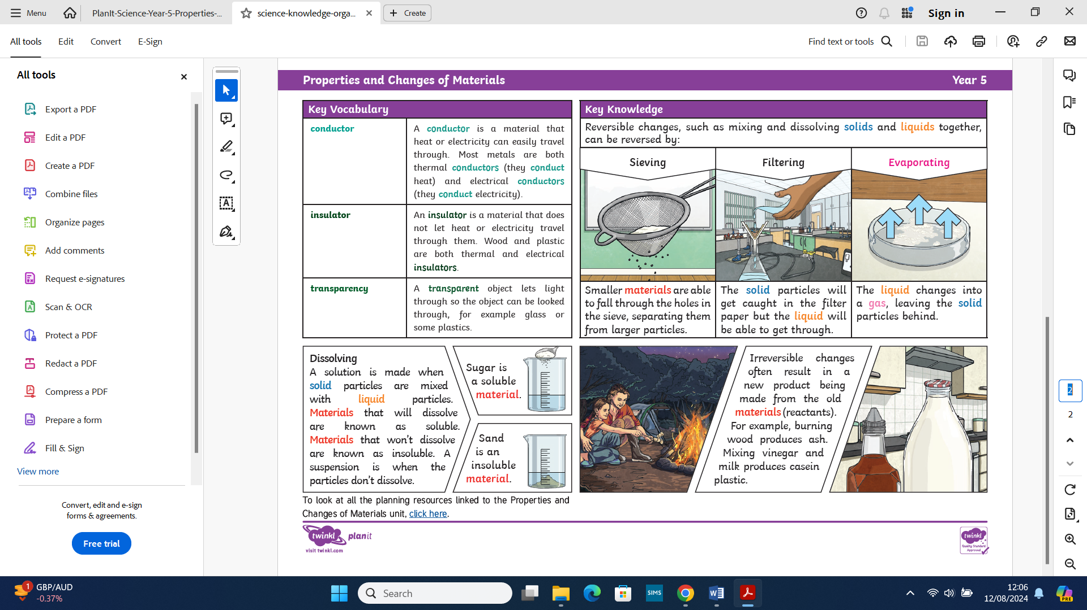

What you already know:
- You can compare and group materials according to whether they are solids, liquids or gases.

- You can observe that some materials change state when they are heated or cooled, and measure or research the temperature of when that happens (in degrees Celsius).

- You are able to identify the part played by evaporation and condensation in the water cycle and associate the rate of evaporation of change with temperature.
- You can make systematic and careful observations and, where appropriate, take accurate measurements using standard units, use a range of equipment, including thermometers.



