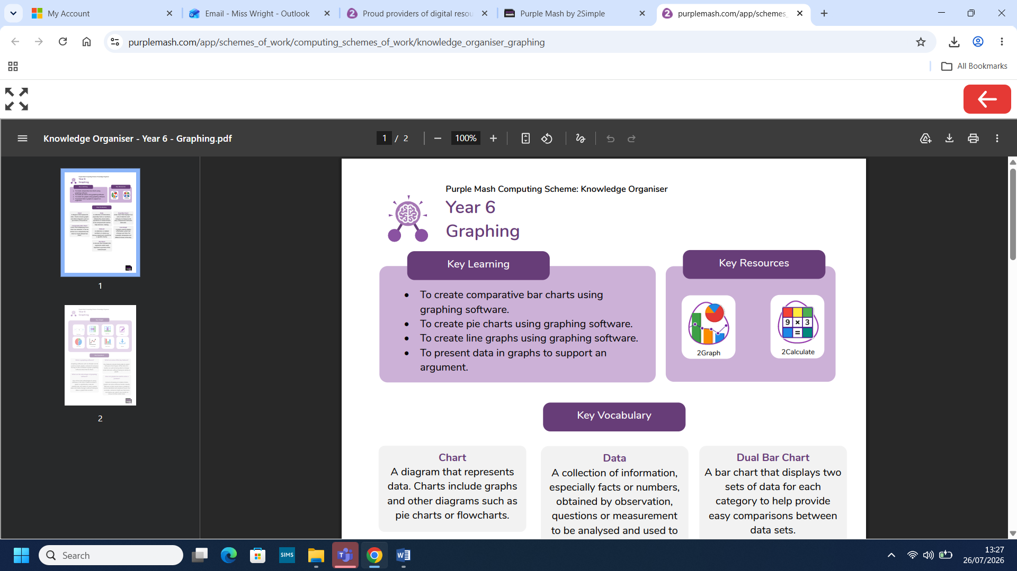
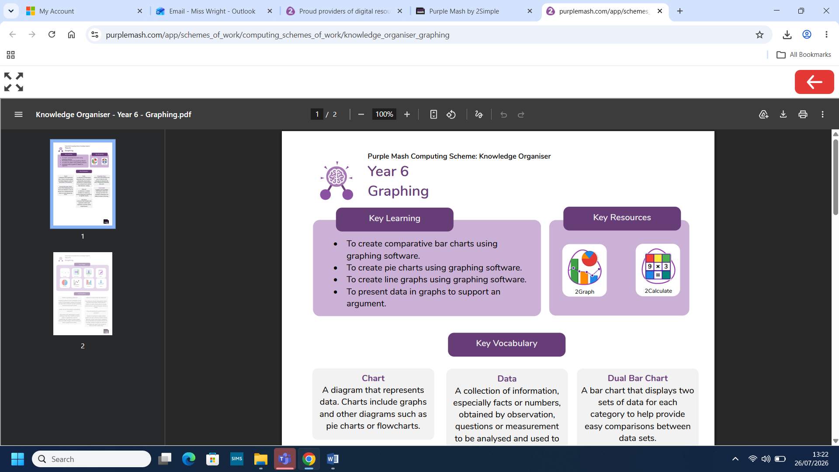
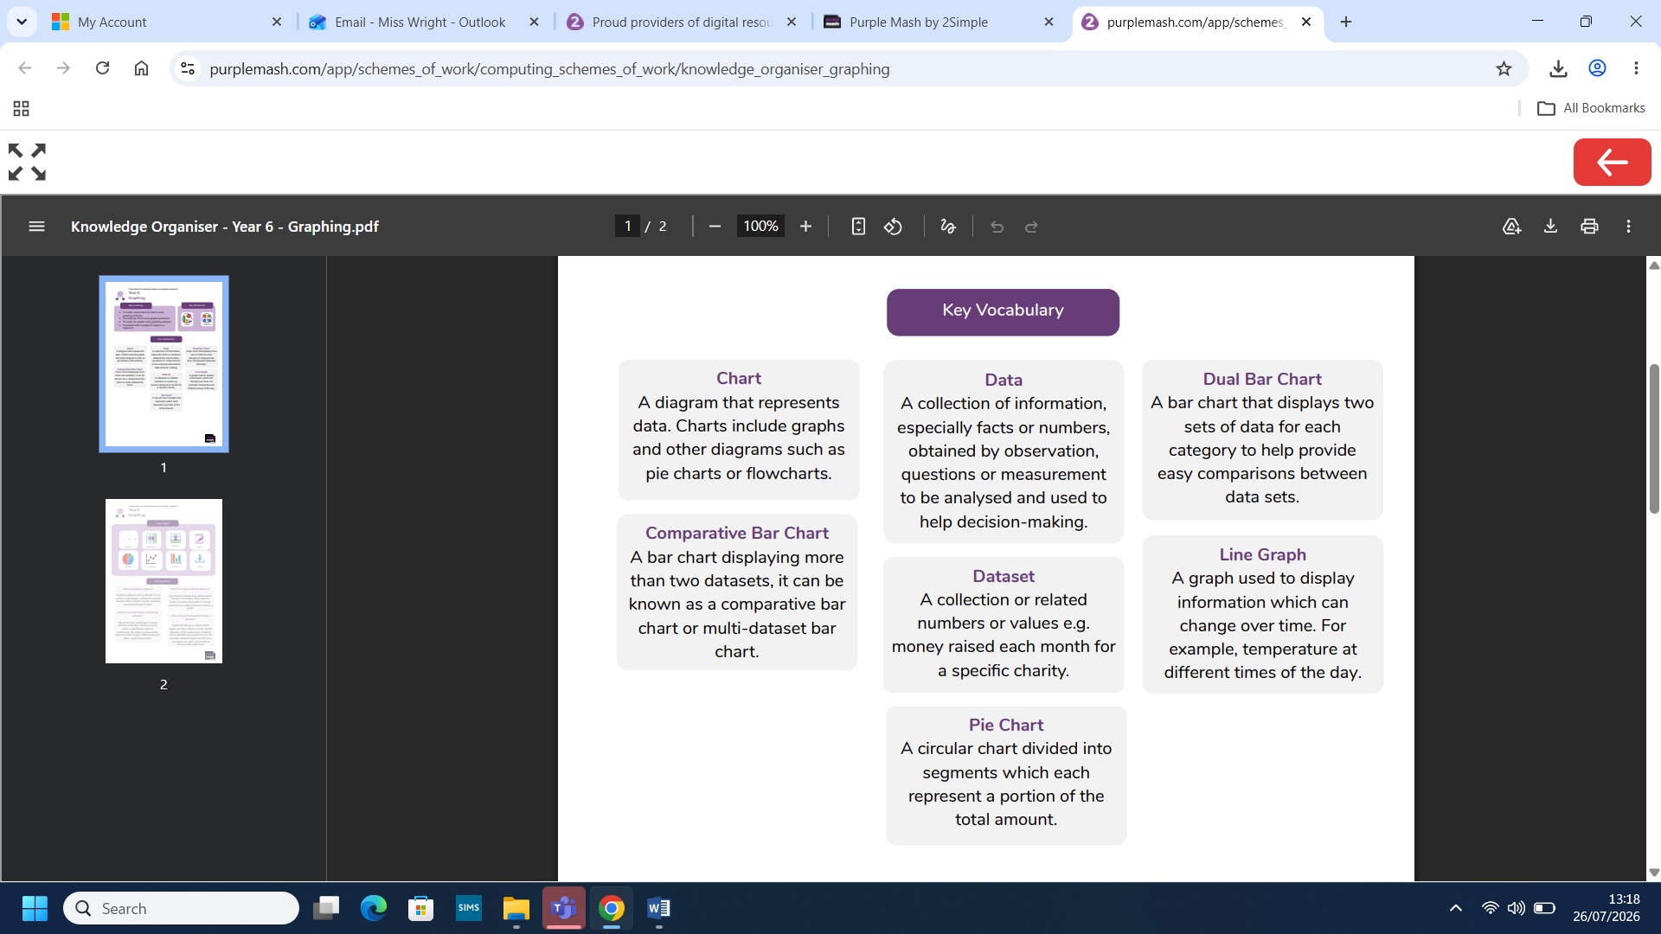
Computing: Graphing
What you already know:

- We can use basic spreadsheet formulae correctly.
- We can use 2Calculate to create and interpret line graphs that show how data changes over time.
- We can analyse data by using spreadsheets to identify patterns.

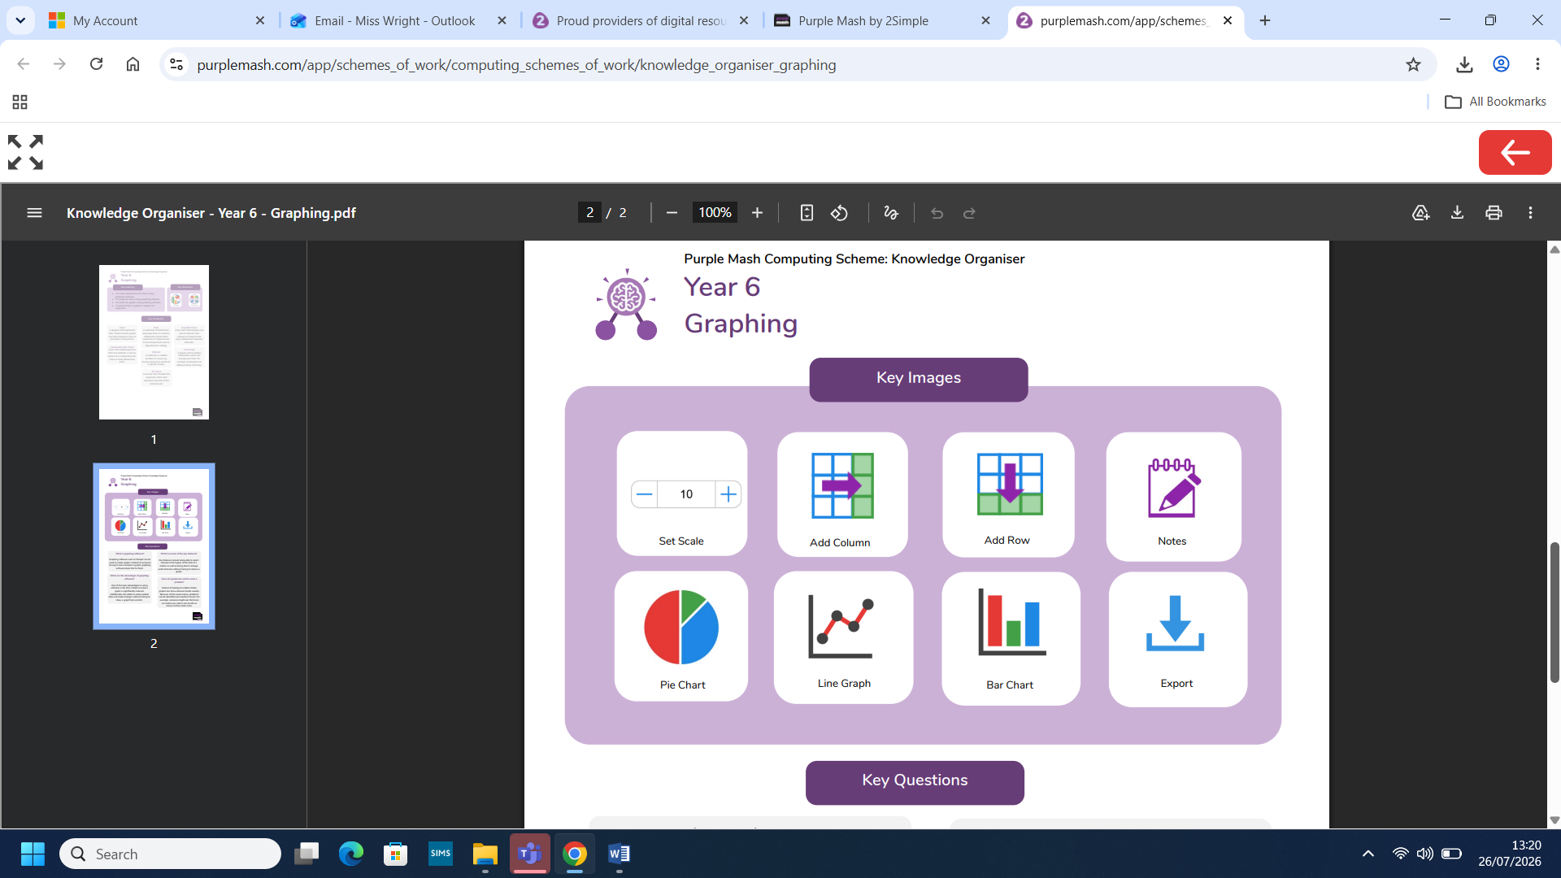
What you will know by the end of this unit:

- We will create comparative bar charts using graphing software.
- We will create pie charts using graphing software.
- We will create line graphs using graphing software.
- We will present data in graphs to support an argument.

