Long Term Plan Overview 2026-2027
Year 2 | Term 1 | Term 2 | Term 3 | Term 4 | Term 5 | Term 6
English Texts | 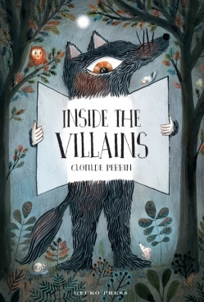 |  | 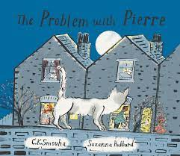 | 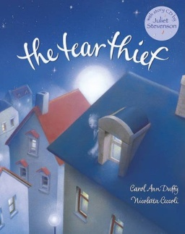 | 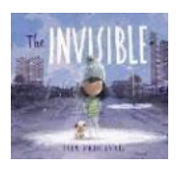 | 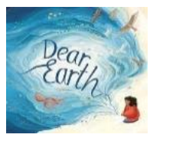
Maths | Place Value/  Addition and Subtraction | Addition and Subtraction/ Shape | Money/ Multiplication and division | Length and height/ Mass, capacity and temperature | Fractions/ Time | Statistics/ Position and direction
Science | Materials |  |  | Animals inc. humans | Plants | Living things and habitats
Computing | E-Safety – Managing Online Information | The Internet  E-Safety – Online Relationships | Route Explorers  E-Safety – Online Reputation | Spreadsheets  E-Safety – Online Bullying | Coding  E-Safety – Privacy and Security | Use of Powerpoint/ Word to present ideas
PE | Striking and field game skills | Invasion Games | Gymnastics/Dance | Net and Wall game skills | Athletics | OAA/ Target games
PSHE  SRE | Friendship  British Values  Zones of Regulation | Safe relationships:  consent,  boundaries and  Trust  Zones of Regulation | Keeping Healthy and Well  Zones of Regulation | Physical Activity and Nutrition  Zones of Regulation | Drug Education  Zones of Regulation | Careers education:  aspiration, learning  to work  Changing and  growing up  Zones of Regulation
History | Mary Seacole |  | Retrieval on Mary Seacole |  | Kings and Queens
Geography | Jamaica/UK- map work |  | Continents  Oceans  Rivers |  |  | Comparing UK locations  Geographical terminology
Art | Sculpting- clay models |  | Drawing- Edgar Degas |  | Painting- watercolour portraits
DT | Design, make and evaluate a boat. |  | Cooking- Design, make and evaluate scones | Design, make and evaluate a moving car |  | Sewing- sock puppets
RE |  | How and why do we celebrate special and sacred times? | Who is Jewish and what do they believe? | What can we learn from sacred books? | What does it mean to belong to a faith community?
Music | Beat and tempo | Perform and sing in groups, parts and solo | Identify and create rhythms including call and response using percussion | Understand simple note values. Compose and record simple rhythms | Use technology to create rhythms.  Compose simple sound scapes using percussion | Begin to learn to play melodies using ocarina.

