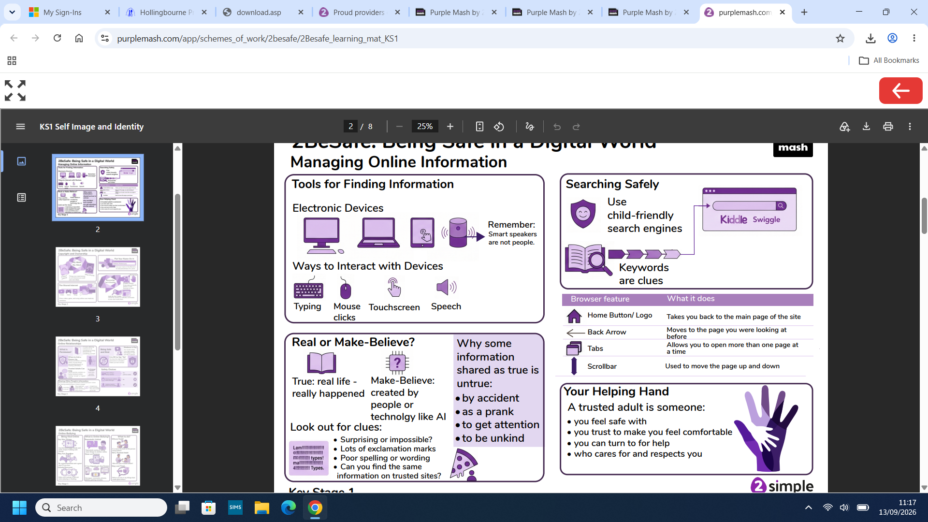
YEAR 2 MANAGING ONLINE INFORMATION
What I will know by the end of this unit:
- I will use simple keywords in search engines.
- I will demonstrate how to navigate a simple webpage to get to information I need (e.g. home, forward, back buttons; links, tabs and sections).
- I will explain what voice activated searching is and how it might be used, and know it is not a real person (e.g. Alexa, Google Now, Siri).
- I will explain the difference between things that are imaginary, ‘made up’ or ‘make believe’ and things that are ‘true’ or ‘real’.
- I will explain why some information I find online may not be real or true.

What I already know:
- I can give simple examples of how to find information using digital technologies, e.g. search engines, voice activated searching).
- I know / understand that we can encounter a range of things online including things we like and don’t like as well as things which are real or make believe / a joke.
- I know how to get help from a trusted adult if I see content that makes me feel sad, uncomfortable worried or frightened.

Key vocabulary
A search engine is a website designed to help people find information online.
Voice activated searching means technology that lets you search the internet or apps by speaking aloud instead of typing.
Imaginary means made up and are not true or real.

