YEAR 2 ONLINE RELATIONSHIPS

Key vocabulary

Communication: sharing of messages, information, thoughts or feelings between people
Offline: not connected to the internet.
Online: connected to the internet.
Permission: It means allowing or being allowed to do something.
Trusted Adults: an adult which can make you feel safe and supported, for example: parents, teachers or family members.
What you already know:
- You can give examples of when I should ask permission to do something online and explain why this is important.

- You use the internet with adult support to communicate with people I know (e.g. video call apps or services).

- You explain why it is important to be considerate and kind to people online and to respect their choices.

- You can explain why things one person finds funny or sad online may not always be seen in the same way by others.
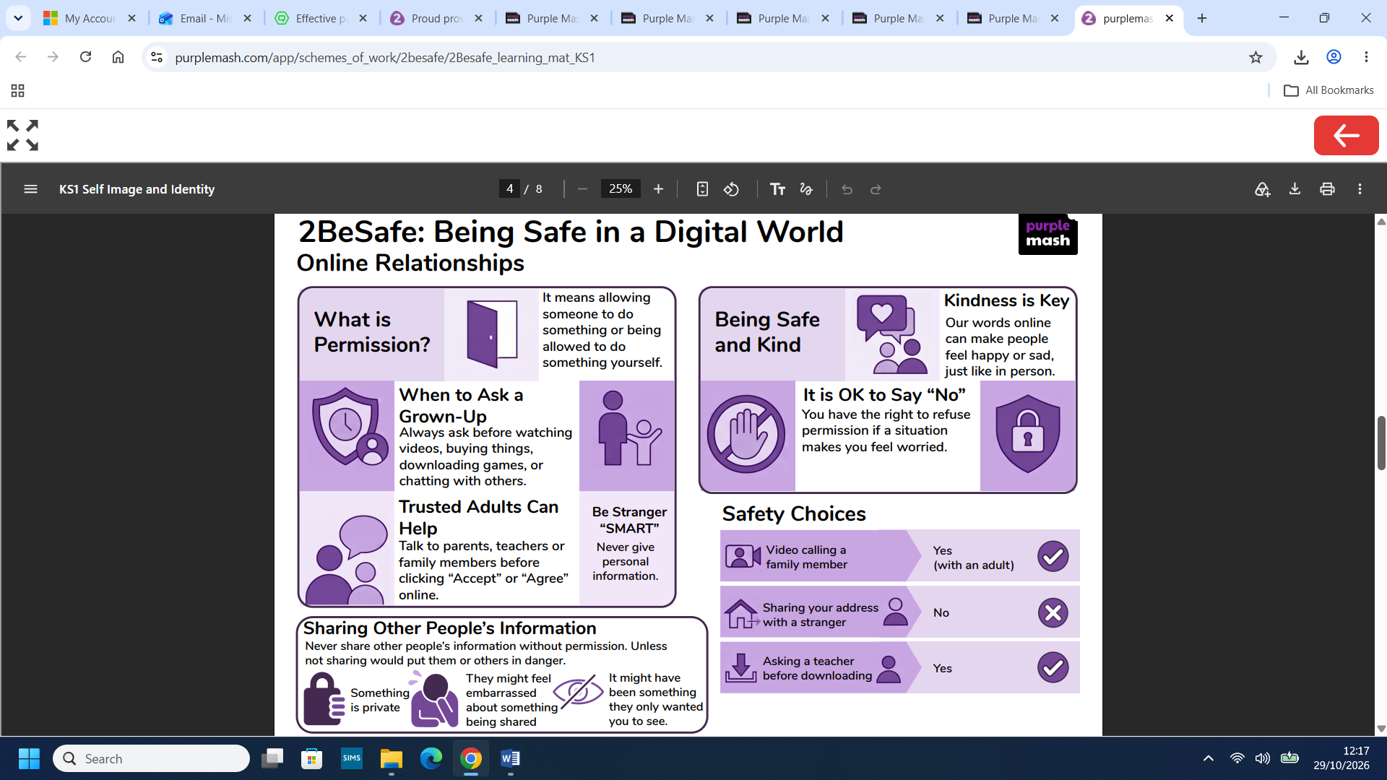
What you will know by the end of this unit:
- You can give examples of how someone might use technology to communicate with others they don’t also know offline and explain why this might be risky.
- You can explain who you should ask before sharing things about yourself or others online.
- You can describe different ways to ask for, give, or deny my permission online and can identify who can help you if you’re unsure.
- You can explain why you have a right to say ‘no’ or ‘you will have to ask someone’. You can explain who can help you if you feel under pressure to agree to something you are unsure about or don’t want to do.
- You can identify who can help you if something happens online without your consent.
- You can explain how it may make others feel if you do not ask their permission or ignore their answers before sharing something about them online.
- You can explain why you should always ask a trusted adult before clicking ‘yes’, ‘agree’ or ‘accept’ online.

