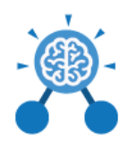
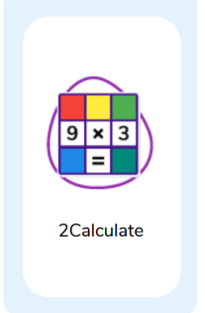
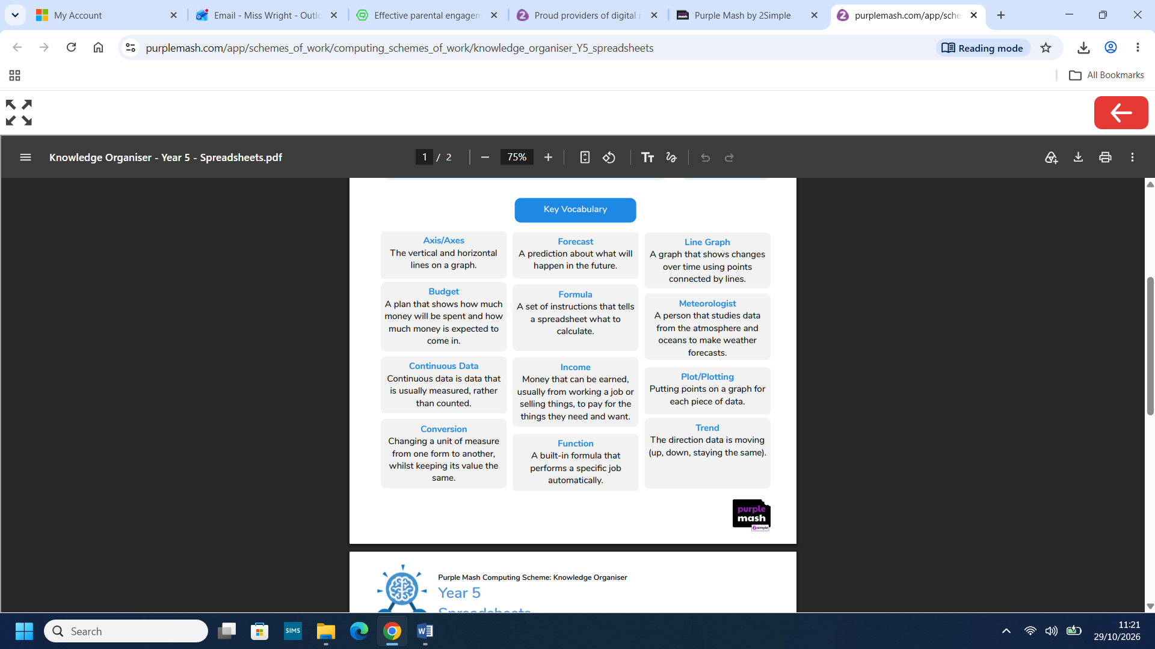
Computing: Spreadsheets

What you already know:
- You understand the layout and features of 2Calculate in Advanced Mode.
- You can use the arrows toolbar to be able to automatically total rows and columns.
- You can use simple formulae in a spreadsheet by using the formula wizard.
- You can use advanced formulae in a spreadsheet to calculate totals, averages and to find the highest and lowest values.
- You can apply spreadsheet skills to solve real-world problems.
- You can design and use a spreadsheet to answer a series of questions.

What you will know by the end of this unit:
- You will refresh and extend understanding of formulae and functions from previous learning.
- You will use formulae in 2Calculate to convert measurements between different units.
- You will use 2Calculate to create and interpret line graphs that show how data changes over time.
- You will analyse weather data by using spreadsheets to identify patterns.
- You will use spreadsheets to plan and budget for an event.
- You will use a spreadsheet to plan a holiday.


