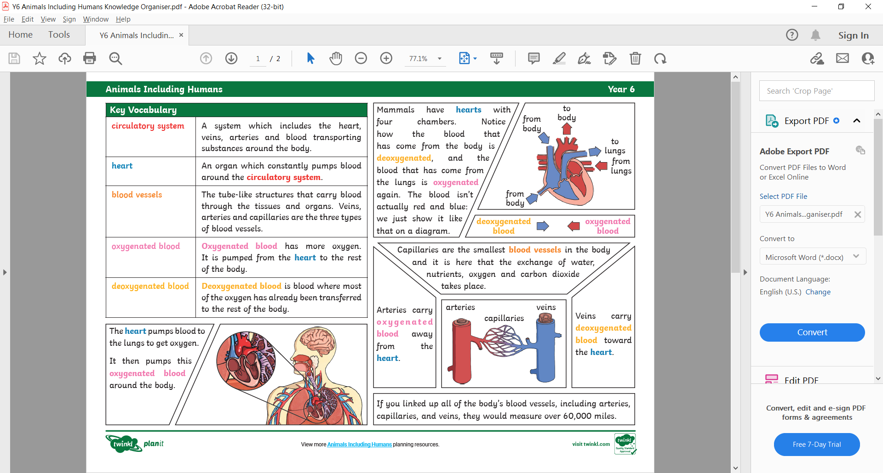
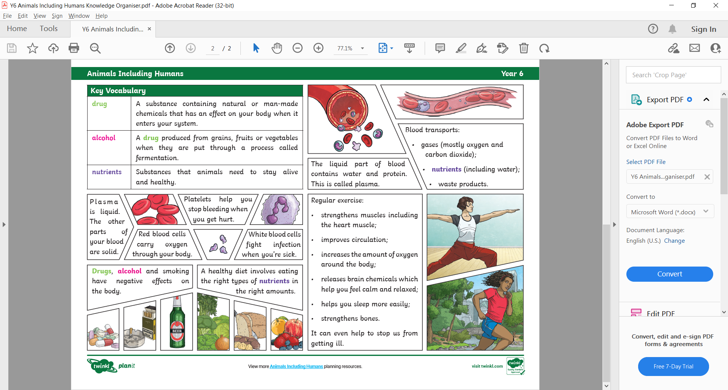

Animals including humans - Years 5&6
Key vocabulary
What we already know:
- That animals including humans need the right types and amount of nutrition.
- You will understand how different food groups contribute to different parts of the body remaining healthy.
- You will know the main body parts associated with the skeleton and muscles and the digestive system and their function.
- You will already be able to take accurate measurements, record findings using drawings, labelled diagrams, keys, bar charts and tables and use results to draw simple conclusions.

What we will know by the end of this unit:

- We will describe changes as humans develop to old age (including puberty, gestation periods of animals compared to humans).
- We will be able to identify and name the main parts of the human circulatory system.
- We will describe functions of heart, blood vessels and blood.
- We will recognise the impact of diet, exercise, drugs and lifestyle on body function.
- We will describe ways in which water and nutrients are transported in animals and humans.
- We will take measurements with increasing accuracy and precision, taking repeat readings when appropriate. The data will be recorded and presented in a table and line graph. Identify causal relationships shown by data.



